Apni AMC Handover Document
Production Instance Website URL :- http://masterdemo1.apniamc.com/auth/login
UAT Website URL :- http://uat.apniamc.com/auth/login
Apni AMC Android Application link :- https://play.google.com/store/apps/details?id=com.apnimaster.demo&hl=en_NZ&gl=US

Production and UAT Website Login ID & Password :-
Login ID :- vishal@mukesoft.com
Password :- 123456

Production Website Technician Login ID & Password :-
Login ID :- gaurav@mukesoft.com
Password :- 123456

UAT Website Technician Login ID & Password :-
Login ID :- pankaj.mukesoft@gmail.com
Password :- 123456

Master credentials (Information about the expiry of website and many more) :-
http://uat.mukesoft.com/apniamc_master/login.php
Login ID :- vishal@mukesoft.com
Password :- vishal123

Master script path for adding new column (USING FTP) :-
Path | Descriptions
/var/www/laravel/apniamc_master/demo-db.sql | This script will be get executed every time, whenever a Production instance is created.

Credentials of FTP Login :-
Fields | Type / Password
Protocol | SFTP – SSH File Transfer Protocol
Host | 139.59.41.76
Logon Type | Key File
Key File name | MukeDigi_Proj.ppk --Get this file from Mehul Sir
Username | Root
Password | Vi8Meh*Mu@7$ke

Refer Below screenshot for more FTP details.
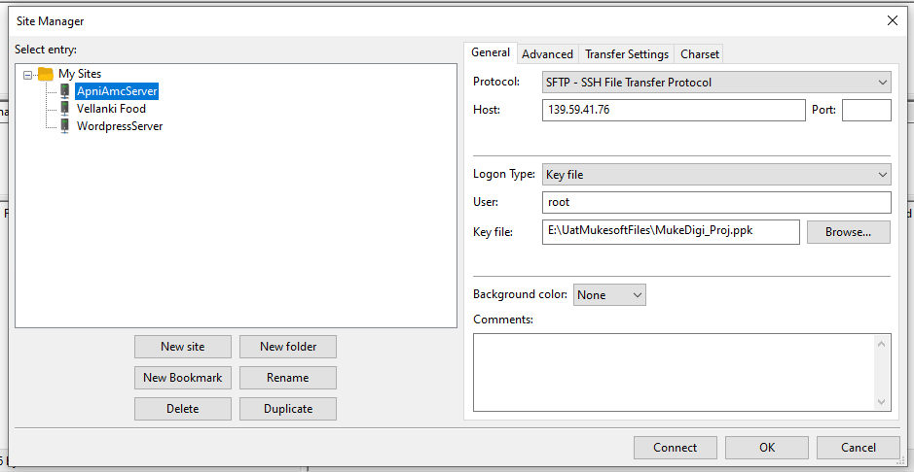

Database Credentials :-
Type of fields | Fields Value
MySQL HOST Address | 139.59.41.76
Username | Mukesoft
Password | jeR4s#2@eD
Database name | apni_amc_master
Port | 3306

Refer Below screenshot for more DATABASE details.
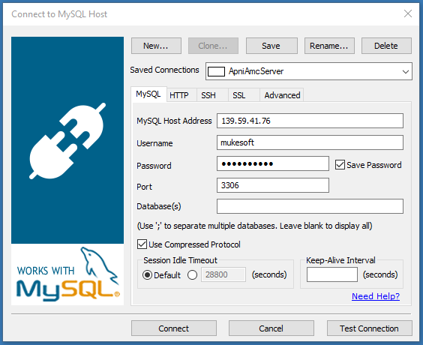
Some important File paths to works :-
Path | Descriptions
/var/www/laravel/apni-amc-clients-live/amc-master-ver1/apniamc-version1/resources/views/ | View Files path. (HTML)
/var/www/laravel/apni-amc-clients-live/amc-master-ver1/apniamc-version1/app/Http/Controllers/ | Controller Files path. (Logic Works).
/var/www/laravel/apni-amc-clients-live/amc-master-ver1/apniamc-version1/app | Models Files path. (All the PHP Files).

Following are the list of task that I have done on the website:
1) Adding product description textbox in Add product.
- Product Description textbox is created to described the details about some products.
- The following are the path of folder where I have made changes :
Path | Descriptions
/var/www/laravel/apni-amc-clients-live/amc-master-ver1/apniamc-version1/resources/views/manage_product/create.blade.php | Changes from line 44-53
/var/www/laravel/apni-amc-clients-live/amc-master-ver1/apniamc-version1/app/Http/Controllers/ManageProduct/ManageProductController.php | Changes in function store()
/var/www/laravel/apni-amc-clients-live/amc-master-ver1/apniamc-version1/app/Products.php - New column have to be created in database. | Changes on line no. 11. i.e prod_desc

2) Adding Instruction textbox in Create service.
- Instructions textbox is created to given some instruction to technician by customers.
- The following are the path of folder where I have made changes :
Path | Descriptions
/var/www/laravel/apni-amc-clients-live/amc-master-ver1/apniamc-version1/resources/views/services/create.blade.php | Changes from line 391-401
/var/www/laravel/apni-amc-clients-live/amc-master-ver1/apniamc-version1/app/Http/Controllers/Services/ServiceController.php | Changes in line 280, 315 function finalStoreServices()
/var/www/laravel/apni-amc-clients-live/amc-master-ver1/apniamc-version1/app/VendorShipment.php - New column have to be created in database. | Changes on line no. 10. i.e instructions

3) Client Ticket Number textbox in create service.
- Client Ticket number is used to assign a specific number for an important ticket.
- The following are the path of folder where I have made changes :
Path | Descriptions
/var/www/laravel/apni-amc-clients-live/amc-master-ver1/apniamc-version1/resources/views/services/create.blade.php | Changes from line 314-323
/var/www/laravel/apni-amc-clients-live/amc-master-ver1/apniamc-version1/app/Http/Controllers/Services/ServiceController.php | Changes in line 280, 315 function finalStoreServices()
/var/www/laravel/apni-amc-clients-live/amc-master-ver1/apniamc-version1/app/VendorShipment.php | Changes on line no. 10. i.e clientticketno

- Filter task for Client Ticket number. Filter task has been done on manage service page.
- The following are the path of folder where I have made changes :
Path | Descriptions
/var/www/laravel/apni-amc-clients-live/amc-master-ver1/apniamc-version1/resources/views/delivery/index.blade.php | Changes from line 362-377
/var/www/laravel/apni-amc-clients-live/amc-master-ver1/apniamc-version1/app/Http/Controllers/Delivery/ManageDeliveryController.php | Changes in line 226-239 function index()

4) Adding of Radio button “PM and CM” in Create service.
- This radio button has been added for service type option in create service page.
- The following are the path of folder where I have made changes :
Path | Descriptions
/var/www/laravel/apni-amc-clients-live/amc-master-ver1/apniamc-version1/resources/views/services/create.blade.php | Changes from line 412-413

- Filter task for PM and CM. Filter task has been done on manage service page.
- The following are the path of folder where I have made changes :
Path | Descriptions
/var/www/laravel/apni-amc-clients-live/amc-master-ver1/apniamc-version1/resources/views/delivery/index.blade.php | Changes from line 250-259

5) Enable Support Ticket Creation on email in setting section.
- This task is used to send the mail to the support system of a company. An email template has been created which will be sent to the company support.
Path | Descriptions
/var/www/laravel/apni-amc-clients-live/amc-master-ver1/apniamc-version1/resources/views/settings/featuresettings.blade.php | Changes from line 88-103,140-143.
/var/www/laravel/apni-amc-clients-live/amc-master-ver1/apniamc-version1/app/Http/Controllers/Settings/SettingsController.php | Changes in line 70-79 function savefeaturesettings()
/var/www/laravel/apni-amc-clients-live/amc-master-ver1/apniamc-version1/app/Http/Controllers/Service/ServiceController.php | Changes from line 336-359, 372-380, 414-425.

6) Showing Last 48 Hour Services in manage service.
- The main aim of this task is to show all the pending services from last 48 hrs in manage services page.
- The following are the path of folder where I have made changes :
Path | Descriptions
/var/www/laravel/apni-amc-clients-live/amc-master-ver1/apniamc-version1/resources/views/delivery/index.blade.php | Changes from line 438, 1398-1678,3377-3397.
/var/www/laravel/apni-amc-clients-live/amc-master-ver1/apniamc-version1/app/Http/Controllers/Delivery/ManageDeliveryController.php | Changes in line 625-732 function index()

7) Internal External Admin and technician task
- The main purpose of internal external task was to assign a ticket to external admin. So that external admin can assign his/her technician for that particular ticket.
- The following are the path of folder where I have Added a dropdown for internal and external in manage technician and admin
Path | Descriptions
/var/www/laravel/apni-amc-clients-live/amc-master-ver1/apniamc-version1/resources/views/bikers/create.blade.php | Made changes in Html file from line 279-289 for manage technician.
/var/www/laravel/apni-amc-clients-live/amc-master-ver1/apniamc-version1/resources/views/manage_admin/create.blade.php | Made changes in Html file from line 177-186 for manage admin.

- The following is the path of folder where I Added all external admin dropdown in manage service modal.
Path | Descriptions
/var/www/laravel/apni-amc-clients-live/amc-master-ver1/apniamc-version1/resources/views/delivery/index.blade.php | Made changes from line 1958-1967 for showing external admin section in bootstrap modal.
 | Made changes from line 2463-2496 for showing external admin list in modal pop-up

- The following is the path of folder where the changes I’ve made after assigning ticket to external admin in controller file.

Path | Descriptions
/var/www/laravel/apni-amc-clients-live/ amc-master-ver1/ apniamc-version1/app/Http/Controllers/Delivery/ ManageDeliveryController.php | Made changes from line 1984 – 2022 in updatestatus1() function

- The following is the path of folder where I’ve made changes in controller file for filtering task according to the external and internal admin point of view.
Path | Descriptions
/var/www/laravel/apni-amc-clients-live/amc-master-ver1/apniamc-version1/app/Http/Controllers/Delivery/ManageDeliveryController.php | Changes from line 105 – 333

- The following is the path of folder where I’ve made changes in controller file for showing only Assigned ticket list.
Path | Descriptions
/var/www/laravel/apni-amc-clients-live /amc-master-ver1/ apniamc-version1/ app/Http/Controllers/Delivery/ManageDeliveryController.php | Made change from line 310 - 332 for Today Services Section
 | Made change from line 461 - 471 for Past Service Section
 | Made change from line 575 - 594 for Future Service Section
 | Made change from line 704 - 725 for Last 48 hr Service Section

- The following is the path of files where I’ve made changes for showing only external technician.
Path | Descriptions
/var/www/laravel/apni-amc-clients-live /amc-master-ver1/apniamc-version1/ app/Http/Controllers/Delivery/ManageDeliveryController.php | Made changes from line 875 – 898 for showing external technician only.

8) Changing SMS Code.
- The Gupshup SMS gateway code has been commented in the manage delivery controller. Instead of it, I have uploaded the dovesoft SMS gateway code.
- Dovesoft Api link :- sms.mukesoft.com/submitsms.jsp?
Path | Descriptions
/var/www/laravel/apni-amc-clients-live/amc-master-ver1/apniamc-version1/app/Http/Controllers/Delivery/ManageDeliveryController.php | Changes in line 1503-1551 function assignbiker()

Cronjobs (need to be added by Mehul sir).

