Code Optimization
- The code optimization in the synthesis phase is a program transformation technique, which tries to improve the intermediate code by making it consume fewer resources (i.e. CPU, Memory) so that faster-running machine code will result.

Before Code Optimization
The purpose of this optimization for decrease the load to the server.

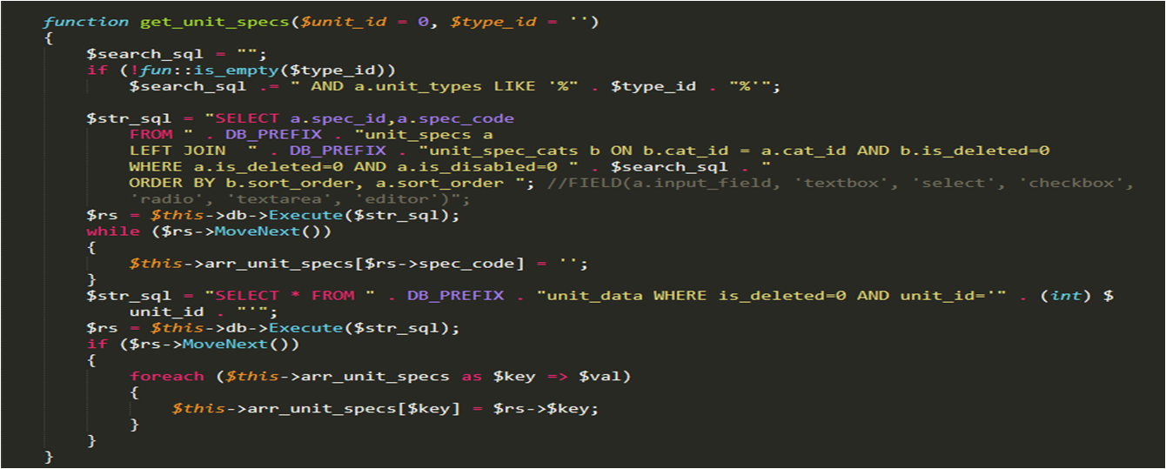
After Code Optimization
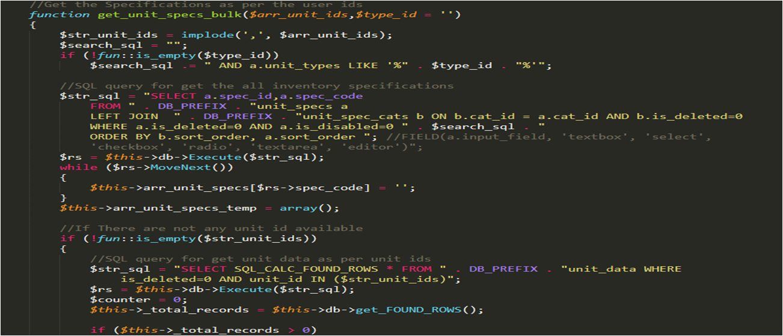

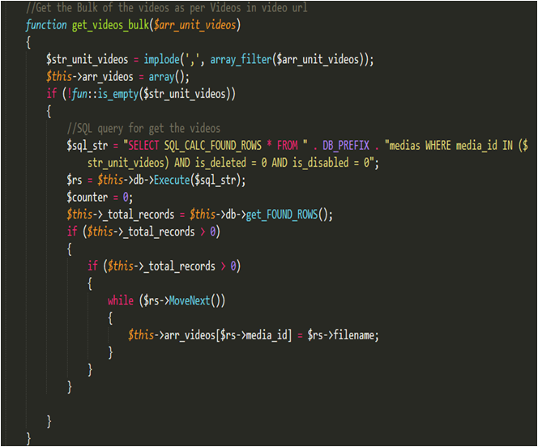
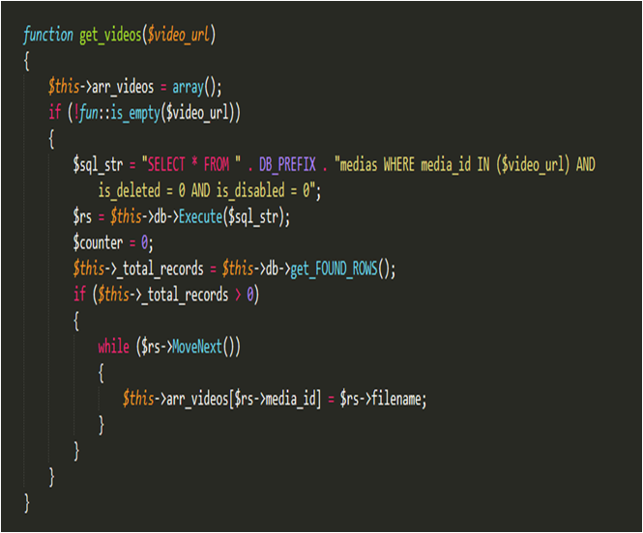
Another Example

Optimization for image:

//Get the Bulk of images as per unit ids
function get_unit_images_bulk_backup($arr_unit_ids)
{
$str_unit_ids = implode(',', $arr_unit_ids);
if (!fun::is_empty($str_unit_ids))
{
//SQL query for get images
$str_sql = "SELECT * FROM " . DB_PREFIX . "unit_images WHERE is_deleted=0 AND unit_id IN ($str_unit_ids) ORDER BY sort_order,filename ASC";
$rs = $this->db->Execute($str_sql);
$counter = 0;
$this->_total_records = $this->db->get_FOUND_ROWS();
$this->arr_images = array();

while ($rs->MoveNext())
{
$url = $rs->file_location . $rs->filename;
$thumbnail = $rs->file_location . 'thumbnail/' . $rs->filename;

if (_PROJECT_MODE == 'LOCAL' && !file_exists(UPLOADS_FS_DIR . $url))
{
$url = LOCAL_DEV_IMAGE_UPLOAD . $url;
$thumbnail = LOCAL_DEV_IMAGE_UPLOAD . $thumbnail;
}
else
{
$url = WS_RIDE_DIGITAL . $url;
$thumbnail = WS_RIDE_DIGITAL . $thumbnail;
}
$this->arr_images[$rs->unit_id][]= array(
'image_id' => $rs->image_id,
'unit_id' => $rs->unit_id,
'sort_order' => $rs->sort_order,
'image_title' => $rs->image_title,
'url' => $url,
'thumbnail' => $thumbnail
);
}

}
}

