**Vellanki Foods Website Handover Document**

Website URL :- https://estore.vellankifoods.com/

Admin Website URL :- https://estore.vellankifoods.com/admin/

Credentials of FTP Login :-

Protocol : FTP

Host : 208.91.198.42

Logon Type : Ask for password

Username : vella3bv

Password : Vfs!@Cp1234

Credentials of Admin Panel Login :-

Username : admin

Password : vella3bv

Note :- Some important file paths guide.

**Template File paths :-**

|  |  |
| --- | --- |
| **Path** | **Descriptions** |
| /public_html/estore/catalog/view/theme/default/template | View Files. (HTML) |
| /public_html/estore/system/storage/modification/catalog/view/theme/default/template | For header files and many more like Checkout. |

**Controller File paths :-**

|  |  |
| --- | --- |
| **Path** | **Description** |
| /public_html/estore/catalog/controller | Controller Files (Logic Works). |
| /public_html/estore/system/storage/modification/catalog/controller | Controller for header file. |

**Error Log File paths :-**

|  |  |
| --- | --- |
| **Path** | **Description** |
| /public_html/estore/error_log | Error Log file path (for finding errors). |

**This all are the works which I have done since from March 2020.**

1. Mobile Number not showing in CCAvenue Work.

As some of the customers was haven’t provided the mobile number in past, due to this while making payment their mobile number was not showing. To solve this, I have done some development in file of ../checkout/payment_address.tpl & same code like in shipping_address.tpl files too like this:

var a = $('#address_id :selected').text(); //Will give the address details :-

“Gaurav Vishwakarma, Khar East, Mumbai = 400051, Khar, Maharashtra, India, 9199999999”

var b = a.split(' '); //This will split the text using space :-

["Gaurav", "Vishwakarma,", "Khar", "East,", "Mumbai", "=", "400051,", "Khar,", "Maharashtra,", "India,", "9199999999"]

var c = b.pop(); //Poping up the last number which is mobile number.

“9199999999”

//Based on this I’ve given a condition that if “c = Null” then I will redirect the customer to modify the address page and let them enter the mobile number.

if(c=="")

{ alert("Please enter your Phone Number")

window.location.href = "index.php?route=account/address";

}

2. CCAvenue payment option not working work.

This error has been solved by getting the type of error from “**error_log”** file. The error was been based on **encrypting and decrypting of URL**. I basically got one code from github which solved this issue.

The Following is the type of error we are getting while making payment using CCavenue:-

PHP Fatal error: **Uncaught Error: Call to undefined function mcrypt_module_open() in /home/vella3bv/public_html/estore/admin/controller/common/cbdom_main.php:117**

Solved this error by pasting this code in file path of /public_html/estore/admin/controller/common/cbdom_main.php :-

public function encrypt($plainText, $key){

$key = $this->hextobin(md5($key));

$initVector = pack("C*", 0x00, 0x01, 0x02, 0x03, 0x04, 0x05, 0x06, 0x07, 0x08, 0x09, 0x0a, 0x0b, 0x0c, 0x0d, 0x0e, 0x0f);

$openMode = openssl_encrypt($plainText, 'AES-128-CBC', $key, OPENSSL_RAW_DATA, $initVector);

$encryptedText = bin2hex($openMode);

return $encryptedText;

}

public function decrypt($encryptedText, $key){

$key = $this->hextobin(md5($key));

$initVector = pack("C*", 0x00, 0x01, 0x02, 0x03, 0x04, 0x05, 0x06, 0x07, 0x08, 0x09, 0x0a, 0x0b, 0x0c, 0x0d, 0x0e, 0x0f);

$encryptedText = $this->hextobin($encryptedText);

$decryptedText = openssl_decrypt($encryptedText, 'AES-128-CBC', $key, OPENSSL_RAW_DATA, $initVector);

return $decryptedText;

}

Note :- I have disabled the same function code which was getting used before in that same file.

3. Disabling Some particular delivery Date’s. **(Important as its asked to do at manytime)**

This work I have done for disabling some particular dates. In case Vellanki owners asked to disabled some date. Kindly follow this step to make changes.

Move to this folder path :-

/public_html/estore/system/storage/modification/catalog/view/theme/default/template/checkout/shipping_method.tpl in 100 - 120 lines.

var city_name = $('#city_name').val();

var country_name = $('#country_name').val();

if(country_name == 'India'){

if(city_name == 'hyderabad'){

//If have asked to disabled the **local delivery**. Then just add the date in (‘MM/DD/YYYY’) format.

var holidays = [moment('01/14/2021'),moment('01/15/2021')]

}else{

//If have asked to disabled **national** order, then set the date here.

var holidays = [moment('01/14/2021'),moment('01/15/2021'),moment('01/16/2021')]

}

}else{

//If have asked to disabled the **international** order’s.

var holidays =[moment('01/14/2021'),moment('01/15/2021')]

}

4. Images were not able to change by vellanki owners work.

The following error was getting occurred while users from admin panel trying to change images.

PHP Fatal error: **Allowed memory size of 268435456 bytes exhausted (tried to allocate 28672 bytes) in /home/vella3bv/public_html/estore/system/library/image.php on line 26.**

This Fatal error was found on error_log file.

This work I have solved by setting the **memory limit from 256M to 512M** using php **ini_set** method.

echo ini_get("memory_limit"); //Will give the output of actual memory limit.

**ini_set("memory_limit","512M");** //Will set the memory limit to 512Mb.

5. Updating Courier Rate using admin panel work. **(Important as its asked to do at manytime)**

For changing courier rate please follow this step carefully:-

**Login to the admin panel :-** [**https://estore.vellankifoods.com/admin**](https://estore.vellankifoods.com/admin)

1. Click on “**Extensions**” from left menu.
2. Click on “**Extensions**”.
3. Choose the Extension Type as “**Shipping**”.
4. Slightly scroll down to the bottom. And at **“Weight Based Shipping”** option click on the **“EDIT”** i.e (Pen icon) option.
5. Now Change the **“RATES”** accordingly by selecting the **countries** or cities i.e (Hyderabad, UK, Canada). Click on **SAVE** button.

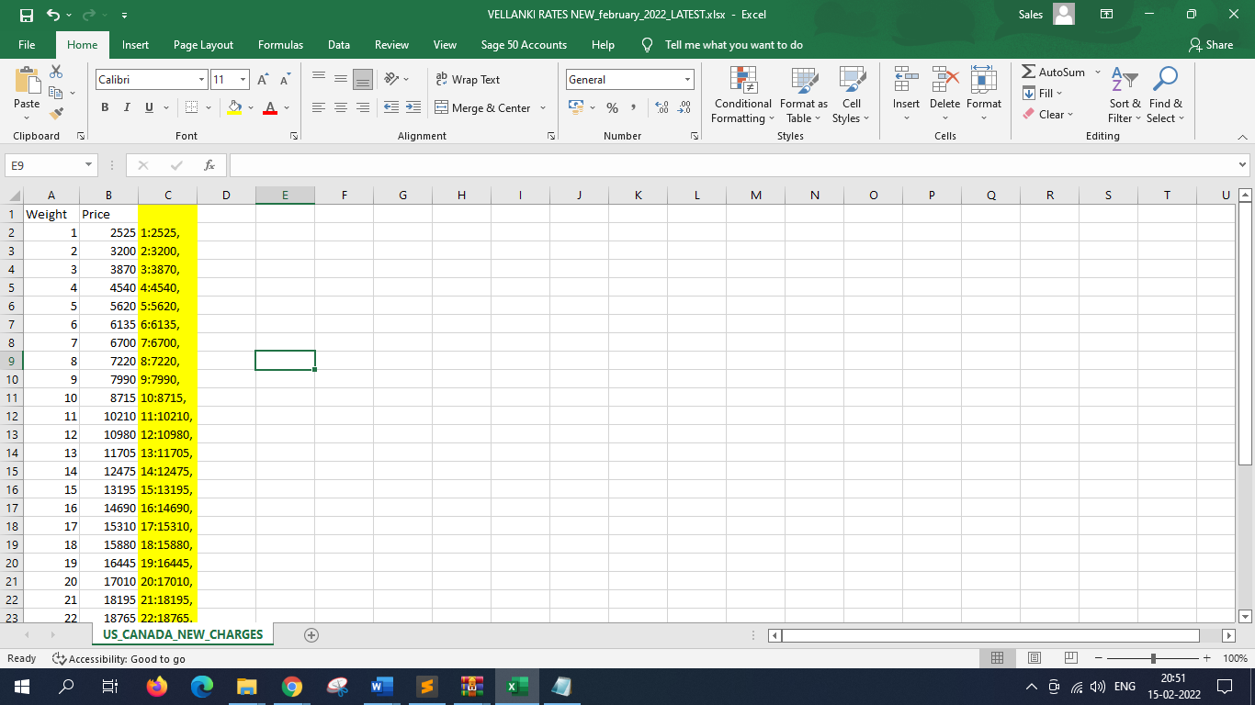

1. To edit the **“RATES”** in the menu. we have to convert the data in proper format shown in the excel sheet.
2. To convert the data in that format type this formula in excel **CONCATENATE(A2,”:”,B2,”,”).**
3. Then copy paste the values in the “RATES” Menu. And click the save button.
4. Then check the website that values are updated or not
5. To check the **“RATES”** in web site. Select any one product and give add to card
6. Then go to card and select the weight and Quantity of the product then click **“check out”.**

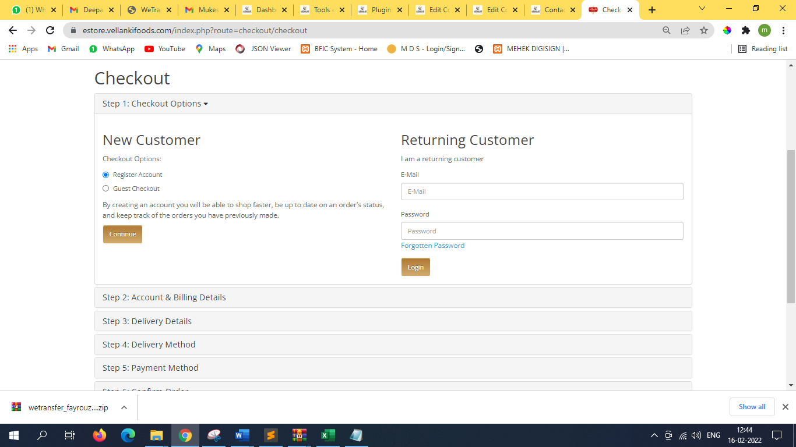

1. Then select the **“Guest Checkout”** in the form and click continue.

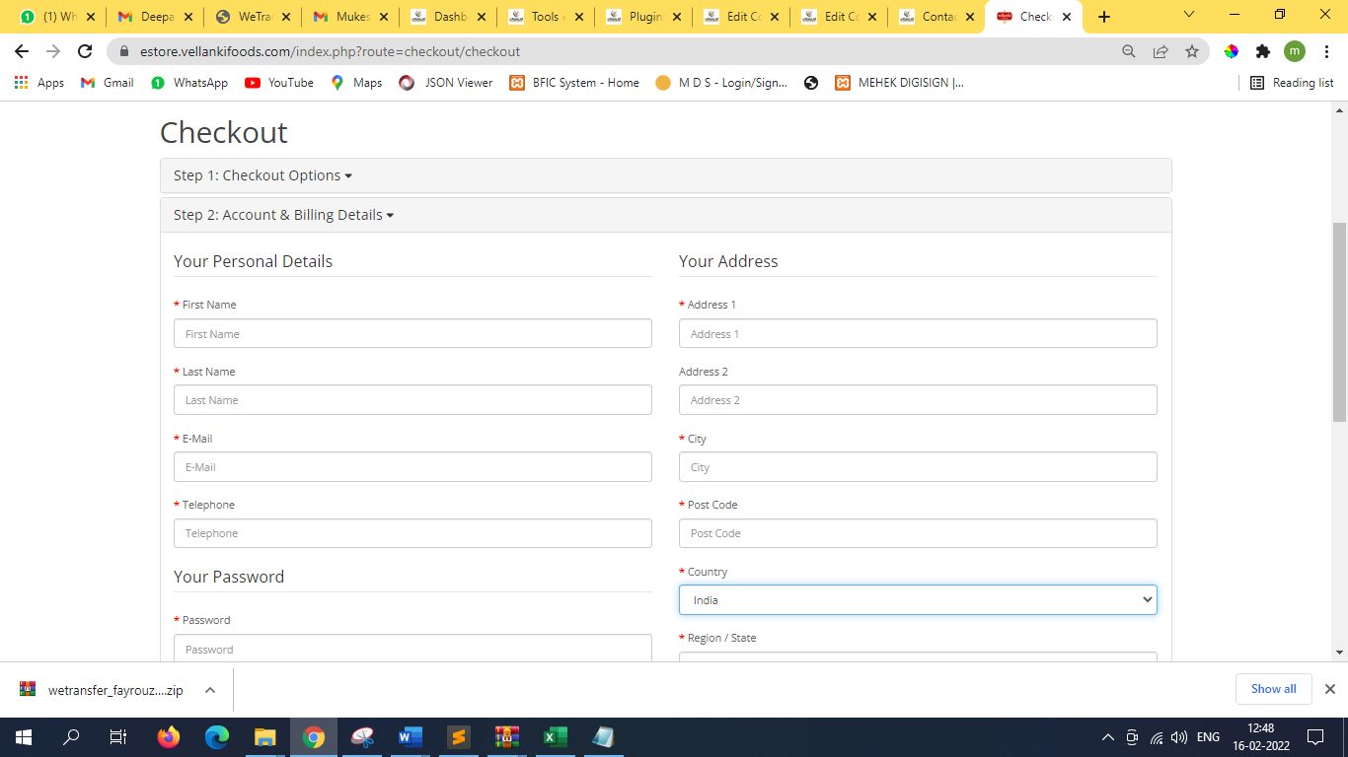

1. Fill all the basic details and select the updated value country name in the **“Country**” field and select any Region and state and click continue.
2. In **“Delivery Method”** it will show the Rates of the selected product. check the Rate values with updated values that all Rate values are updated or not.
3. If the values are same as updated values then **“Rates”** are updated successfully.

6. Disabling Payment Gateway Option from admin panel. **(Important as its asked to do at manytime)**

For Disabling payment gateway, please follow this steps:-

**Login to the admin panel :-** [**https://estore.vellankifoods.com/admin**](https://estore.vellankifoods.com/admin)**.**

1. Click on “**Extensions**” from left menu.
2. Click on “**Extensions**”.
3. Choose the Extension Type as “**PAYMENTS**”.
4. Click on the **“EDIT”** option of the **Payment gateway** which you want to enabled/disabled.
5. Change the **“STATUS”** option to Enabled/Disabled, which you want and then click on **SAVE** button.

7. Header file path to change any slogan for company **(Important as its asked to do at manytime)**.

For making any changes regarding header file i.e (Vellanki Food Login, Menu bar And Search bar) kindly follow this path.

|  |  |
| --- | --- |
| **Path** | **Description** |
| /public_html/estore/system/storage/modification/catalog/view/theme/default/template/common/header.tpl | Editing for any slogan information. |

8. Checkbox task for only Canada orders.

This work I’ve done for accepting the condition that customer might have to bear the customs charges. This task was like accepting the condition before making any payment.

I have made the changes in file path of :-

|  |  |
| --- | --- |
| **Path** | **Description** |
| /public_html/estore/system/storage/modification/catalog/view/theme/default/template/checkout | At very bottom from line 229-249. |

<?php $disabled_type = '';

if($country_id == '38'){

$disabled_type = 'disabled' ?>

<input type="checkbox" name="surcharges" id="surcharges" onchange="remove_disabled()" />&nbsp;<label style="color: red; font-size: 15px;" for="surcharges">There could be additional surcharges applied because of customs, It might possible that customer's have to bear the charges.</label>

<?php

}?>

<script type="text/javascript">

function remove_disabled() {

if(document.getElementById("surcharges").checked){

document.getElementById("button-shipping-method").disabled = false;

}else{

document.getElementById("button-shipping-method").disabled = true;

}

}

</script>

9. PayuBiz Payment Gateway not giving black screen after making payment.

This work has been done by mehul sir. He made the changes in the file path of :-

|  |  |
| --- | --- |
| **Path** | **Description** |
| /public_html/estore/catalog/controller/extension/payment/payu.php | Changes made from line 107-110. |

//commented by mehul sir on 5-8-20 for disabling blank screen and missing orders

//$order_info = $this->model_checkout_order->getOrder($this->session->data['order_id']);

//commented by mehul sir on 5-8-20 for disabling blank screen and missing orders

$order_info = $this->model_checkout_order->getOrder($this->request->post['txnid']);