**Apni AMC Handover Document**

**Production Instance Website URL** :- <http://masterdemo1.apniamc.com/auth/login>

**UAT Website URL** :- <http://uat.apniamc.com/auth/login>

**Apni AMC Android Application link :-** <https://play.google.com/store/apps/details?id=com.apnimaster.demo&hl=en_NZ&gl=US>

**Production and UAT Website Login ID & Password** :-

Login ID :- vishal@mukesoft.com

Password :- 123456

**Production Website Technician Login ID & Password** :-

Login ID :- gaurav@mukesoft.com

Password :- 123456

**UAT Website Technician Login ID & Password** :-

Login ID :- pankaj.mukesoft@gmail.com

Password :- 123456

**Master credentials (Information about the expiry of website and many more) :-**

<http://uat.mukesoft.com/apniamc_master/login.php>

Login ID :- [vishal@mukesoft.com](mailto:vishal@mukesoft.com)

Password :- vishal123

**Master script path for adding new column (USING FTP) :-**

|  |  |
| --- | --- |
| **Path** | **Descriptions** |
| /var/www/laravel/apniamc_master/demo-db.sql | **This script will be get executed every time, whenever a Production instance is created.** |

**Credentials of FTP Login** :-

|  |  |
| --- | --- |
| **Fields** | **Type / Password** |
| Protocol | SFTP – SSH File Transfer Protocol |
| Host | 139.59.41.76 |
| Logon Type | Key File |
| Key File name | MukeDigi_Proj.ppk --Get this file from Mehul Sir |
| Username | Root |
| Password | Vi8Meh*Mu@7$ke |

**Refer Below screenshot for more FTP details.**

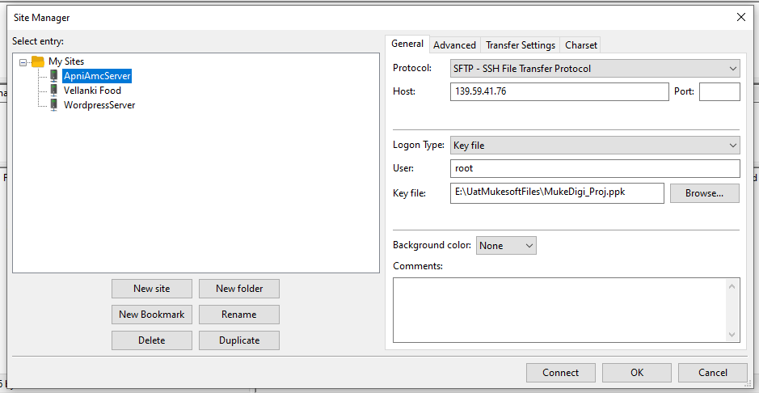

**Database Credentials** :-

|  |  |
| --- | --- |
| **Type of fields** | **Fields Value** |
| MySQL HOST Address | 139.59.41.76 |
| Username | Mukesoft |
| Password | jeR4s#2@eD |
| Database name | apni_amc_master |
| Port | 3306 |

**Refer Below screenshot for more DATABASE details.**

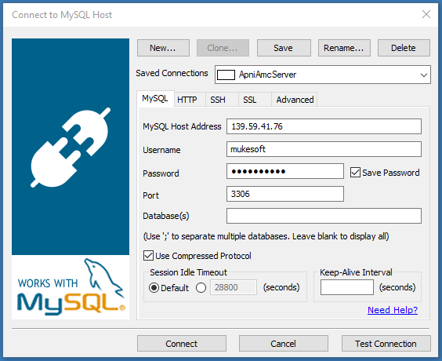

**Some important File paths to works :-**

|  |  |
| --- | --- |
| **Path** | **Descriptions** |
| /var/www/laravel/apni-amc-clients-live/amc-master-ver1/apniamc-version1/resources/views/ | View Files path. (HTML) |
| /var/www/laravel/apni-amc-clients-live/amc-master-ver1/apniamc-version1/app/Http/Controllers/ | Controller Files path. (Logic Works). |
| /var/www/laravel/apni-amc-clients-live/amc-master-ver1/apniamc-version1/app | Models Files path. (All the PHP Files). |

**Following are the list of task that I have done on the website:**

1) Adding product description textbox in Add product.

* Product Description textbox is created to described the details about some products.
* The following are the path of folder where I have made changes :

|  |  |
| --- | --- |
| **Path** | **Descriptions** |
| /var/www/laravel/apni-amc-clients-live/amc-master-ver1/apniamc-version1/resources/views/manage_product/create.blade.php | Changes from line 44-53 |
| /var/www/laravel/apni-amc-clients-live/amc-master-ver1/apniamc-version1/app/Http/Controllers/ManageProduct/ManageProductController.php | Changes in function store() |
| /var/www/laravel/apni-amc-clients-live/amc-master-ver1/apniamc-version1/app/Products.php - New column have to be created in database. | Changes on line no. 11. i.e prod_desc |

2) Adding Instruction textbox in Create service.

* Instructions textbox is created to given some instruction to technician by customers.
* The following are the path of folder where I have made changes :

|  |  |
| --- | --- |
| **Path** | **Descriptions** |
| /var/www/laravel/apni-amc-clients-live/amc-master-ver1/apniamc-version1/resources/views/services/create.blade.php | Changes from line 391-401 |
| /var/www/laravel/apni-amc-clients-live/amc-master-ver1/apniamc-version1/app/Http/Controllers/Services/ServiceController.php | Changes in line 280, 315 function finalStoreServices() |
| /var/www/laravel/apni-amc-clients-live/amc-master-ver1/apniamc-version1/app/VendorShipment.php - New column have to be created in database. | Changes on line no. 10. i.e instructions |

3) Client Ticket Number textbox in create service.

* Client Ticket number is used to assign a specific number for an important ticket.
* The following are the path of folder where I have made changes :

|  |  |
| --- | --- |
| **Path** | **Descriptions** |
| /var/www/laravel/apni-amc-clients-live/amc-master-ver1/apniamc-version1/resources/views/services/create.blade.php | Changes from line 314-323 |
| /var/www/laravel/apni-amc-clients-live/amc-master-ver1/apniamc-version1/app/Http/Controllers/Services/ServiceController.php | Changes in line 280, 315 function finalStoreServices() |
| /var/www/laravel/apni-amc-clients-live/amc-master-ver1/apniamc-version1/app/VendorShipment.php | Changes on line no. 10. i.e clientticketno |

* Filter task for Client Ticket number. Filter task has been done on manage service page.
* The following are the path of folder where I have made changes :

|  |  |
| --- | --- |
| **Path** | **Descriptions** |
| /var/www/laravel/apni-amc-clients-live/amc-master-ver1/apniamc-version1/resources/views/delivery/index.blade.php | Changes from line 362-377 |
| /var/www/laravel/apni-amc-clients-live/amc-master-ver1/apniamc-version1/app/Http/Controllers/Delivery/ManageDeliveryController.php | Changes in line 226-239 function index() |

4) Adding of Radio button “PM and CM” in Create service.

* This radio button has been added for service type option in create service page.
* The following are the path of folder where I have made changes :

|  |  |
| --- | --- |
| **Path** | **Descriptions** |
| /var/www/laravel/apni-amc-clients-live/amc-master-ver1/apniamc-version1/resources/views/services/create.blade.php | Changes from line 412-413 |

* Filter task for PM and CM. Filter task has been done on manage service page.
* The following are the path of folder where I have made changes :

|  |  |
| --- | --- |
| **Path** | **Descriptions** |
| /var/www/laravel/apni-amc-clients-live/amc-master-ver1/apniamc-version1/resources/views/delivery/index.blade.php | Changes from line 250-259 |

5) Enable Support Ticket Creation on email in setting section.

* This task is used to send the mail to the support system of a company. An email template has been created which will be sent to the company support.

|  |  |
| --- | --- |
| **Path** | **Descriptions** |
| /var/www/laravel/apni-amc-clients-live/amc-master-ver1/apniamc-version1/resources/views/settings/featuresettings.blade.php | Changes from line 88-103,140-143. |
| /var/www/laravel/apni-amc-clients-live/amc-master-ver1/apniamc-version1/app/Http/Controllers/Settings/SettingsController.php | Changes in line 70-79 function savefeaturesettings() |
| /var/www/laravel/apni-amc-clients-live/amc-master-ver1/apniamc-version1/app/Http/Controllers/Service/ServiceController.php | Changes from line 336-359, 372-380, 414-425. |

6) Showing Last 48 Hour Services in manage service.

* The main aim of this task is to show all the pending services from last 48 hrs in manage services page.
* The following are the path of folder where I have made changes :

|  |  |
| --- | --- |
| **Path** | **Descriptions** |
| /var/www/laravel/apni-amc-clients-live/amc-master-ver1/apniamc-version1/resources/views/delivery/index.blade.php | Changes from line 438, 1398-1678,3377-3397. |
| /var/www/laravel/apni-amc-clients-live/amc-master-ver1/apniamc-version1/app/Http/Controllers/Delivery/ManageDeliveryController.php | Changes in line 625-732 function index() |

7) Internal External Admin and technician task

* The main purpose of internal external task was to assign a ticket to external admin. So that external admin can assign his/her technician for that particular ticket.
* The following are the path of folder where I have Added a dropdown for internal and external in manage technician and admin

|  |  |
| --- | --- |
| **Path** | **Descriptions** |
| /var/www/laravel/apni-amc-clients-live/amc-master-ver1/apniamc-version1/resources/views/bikers/create.blade.php | Made changes in Html file from line 279-289 for manage technician. |
| /var/www/laravel/apni-amc-clients-live/amc-master-ver1/apniamc-version1/resources/views/manage_admin/create.blade.php | Made changes in Html file from line 177-186 for manage admin. |

* The following is the path of folder where I Added all external admin dropdown in manage service **modal.**

|  |  |
| --- | --- |
| **Path** | **Descriptions** |
| /var/www/laravel/apni-amc-clients-live/amc-master-ver1/apniamc-version1/resources/views/delivery/index.blade.php | Made changes from line 1958-1967 for showing external admin section in bootstrap modal. |
| Made changes from line 2463-2496 for showing external admin list in modal pop-up |

* The following is the path of folder where the changes I’ve made after assigning ticket to external admin in controller file.

|  |  |
| --- | --- |
| **Path** | **Descriptions** |
| /var/www/laravel/apni-amc-clients-live/ amc-master-ver1/ apniamc-version1/app/Http/Controllers/Delivery/ ManageDeliveryController.php | Made changes from line 1984 – 2022 in updatestatus1() function |

* The following is the path of folder where I’ve made changes in controller file for filtering task according to the external and internal admin point of view.

|  |  |
| --- | --- |
| **Path** | **Descriptions** |
| /var/www/laravel/apni-amc-clients-live/amc-master-ver1/apniamc-version1/app/Http/Controllers/Delivery/ManageDeliveryController.php | Changes from line 105 – 333 |

* The following is the path of folder where I’ve made changes in controller file for showing only Assigned ticket list.

|  |  |
| --- | --- |
| **Path** | **Descriptions** |
| /var/www/laravel/apni-amc-clients-live /amc-master-ver1/ apniamc-version1/ app/Http/Controllers/Delivery/ManageDeliveryController.php | Made change from line 310 - 332 for Today Services Section |
| Made change from line 461 - 471 for Past Service Section |
| Made change from line 575 - 594 for Future Service Section |
| Made change from line 704 - 725 for Last 48 hr Service Section |

* The following is the path of files where I’ve made changes for showing only external technician.

|  |  |
| --- | --- |
| **Path** | **Descriptions** |
| /var/www/laravel/apni-amc-clients-live /amc-master-ver1/apniamc-version1/ app/Http/Controllers/Delivery/ManageDeliveryController.php | Made changes from line 875 – 898 for showing external technician only. |

8) Changing SMS Code.

* The Gupshup SMS gateway code has been commented in the manage delivery controller. Instead of it, I have uploaded the dovesoft SMS gateway code.
* Dovesoft Api link :- sms.mukesoft.com/submitsms.jsp?

|  |  |
| --- | --- |
| **Path** | **Descriptions** |
| /var/www/laravel/apni-amc-clients-live/amc-master-ver1/apniamc-version1/app/Http/Controllers/Delivery/ManageDeliveryController.php | Changes in line 1503-1551 function assignbiker() |

Cronjobs (need to be added by Mehul sir).