**Code Optimization**

* The code optimization in the synthesis phase is a program transformation technique, which tries to improve the intermediate code by making it consume fewer resources (i.e. CPU, Memory) so that faster-running machine code will result.

**Before Code Optimization**

The purpose of this optimization for decrease the load to the server.

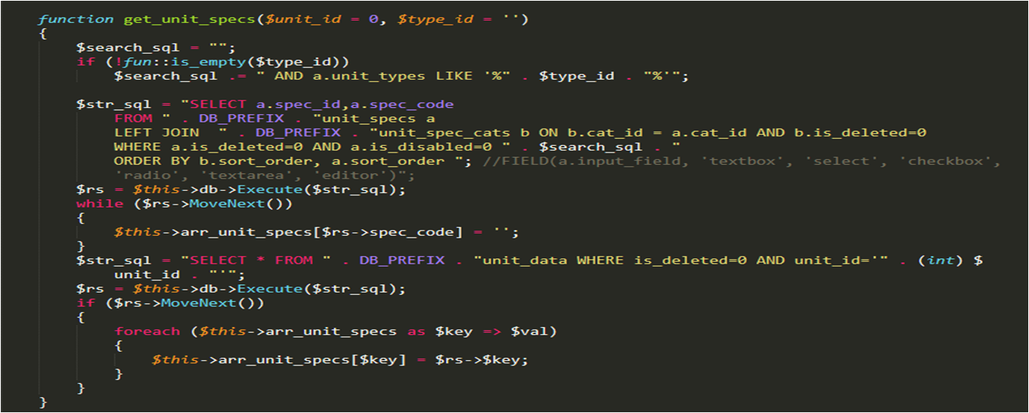

**After Code Optimization**

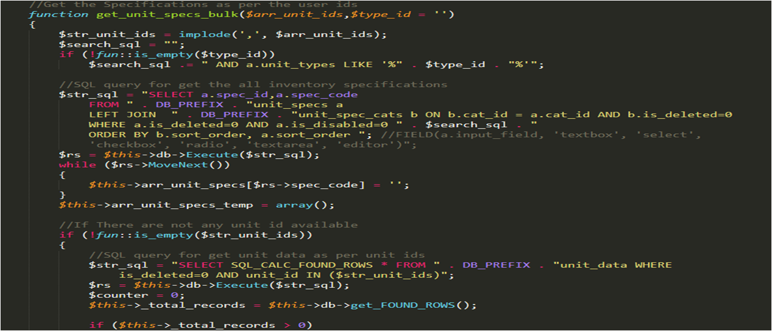

**Another Example**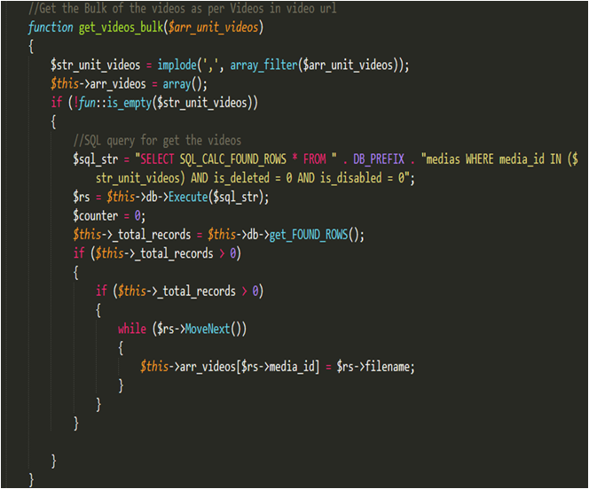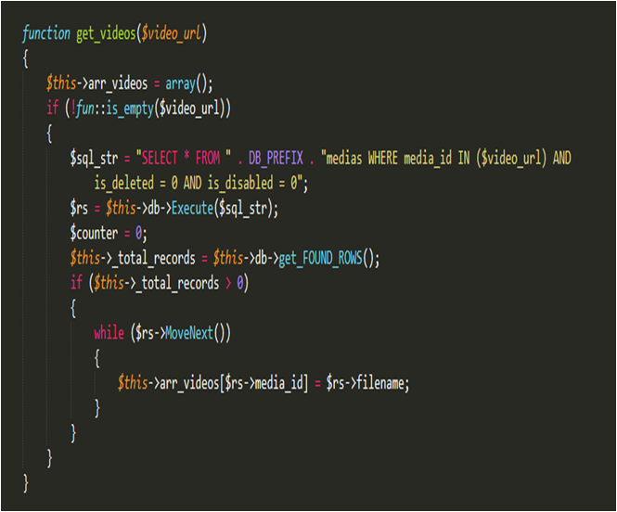

**Optimization for image:**

//Get the Bulk of images as per unit ids

function get_unit_images_bulk_backup($arr_unit_ids)

{

$str_unit_ids = implode(',', $arr_unit_ids);

if (!fun::is_empty($str_unit_ids))

{

//SQL query for get images

$str_sql = "SELECT * FROM " . DB_PREFIX . "unit_images WHERE is_deleted=0 AND unit_id IN ($str_unit_ids) ORDER BY sort_order,filename ASC";

$rs = $this->db->Execute($str_sql);

$counter = 0;

$this->_total_records = $this->db->get_FOUND_ROWS();

$this->arr_images = array();

while ($rs->MoveNext())

{

$url = $rs->file_location . $rs->filename;

$thumbnail = $rs->file_location . 'thumbnail/' . $rs->filename;

if (_PROJECT_MODE == 'LOCAL' && !file_exists(UPLOADS_FS_DIR . $url))

{

$url = LOCAL_DEV_IMAGE_UPLOAD . $url;

$thumbnail = LOCAL_DEV_IMAGE_UPLOAD . $thumbnail;

}

else

{

$url = WS_RIDE_DIGITAL . $url;

$thumbnail = WS_RIDE_DIGITAL . $thumbnail;

}

$this->arr_images[$rs->unit_id][]= array(

'image_id' => $rs->image_id,

'unit_id' => $rs->unit_id,

'sort_order' => $rs->sort_order,

'image_title' => $rs->image_title,

'url' => $url,

'thumbnail' => $thumbnail

);

}

}

}