**STEPS TO INSTALL THE SAGE**

**Prerequisite Steps to run script on Windows system**

* Installed Sage50 software
* Sage 50 compatible sage SDO software
* Xampp (for Apache and MySQL)

* + **Configure Xampp**

1. Go to path “C:\xampp\php” and search for php.ini file
2. Edit php.ini file and allow this extension “extension=php_com_dotnet” or extension="C:\xampp\php\ext\php_com_dotnet.dll"
3. Save php.ini file and start Apache + MySQL

* + Follow the getting started instruction in the SDO help files which involve copying and registering the sg50SDOEnginexxx.dll and the SDOEnginexxx.tlb in the correct directories.

1. **for DLL:**
2. Copy the ActiveX DLL to C:\Windows\SysWOW64 (not System32).
3. Open a command prompt, and register the DLL: C:\Windows\SysWOW64>regsvr32 <DllName or path>
4. Open the registry (type regedit at the command prompt), and search for the DLL name in HKEY_CLASSES_ROOT\WOW6432Node\CLSID. The DLL should be found in a key named HKEY_CLASSES_ROOT\WOW6432Node\CLSID\{GUID} . Copy the GUID to the clipboard.
5. Create a new String value named AppID in this key (not in any of its sub-keys). Set the AppID value to the GUID (including braces).
6. Create a new key: HKEY_CLASSES_ROOT\WOW6432Node\AppID\{GUID} .
7. In this new key, create a String value named DllSurrogate . Leave the value blank.

1. **for tlb:**

1. Open a command prompt, and register the tlb:

    C:\Windows\Microsoft.NET\Framework\v4.0.30319\regtlibv12.exe <tlbname or path>

* + Note (in case you are using win10 there won't be regtlibv12.exe file in your system ):

1. **for regtlibv12.exe:**
2. Install 7-Zip from <https://www.7-zip.org/download.html>
3. Download lessmsi/Less MSIérables from <https://github.com/activescott/lessmsi/releases>

(Or you can use chocolatey [https://chocolatey.org](https://chocolatey.org/) to install both of the above: package names are 7zip and lessmsi respectively.)

1. Download the .NET Framework 4.0 Standalone Installer from <https://www.microsoft.com/en-gb/download/details.aspx?id=17718>
2. Use 7-Zip to open the downloaded dotNetFx40_Full_x86_x64.exe from the previous step, extract the files netfx_Core_x64.msi and netFxCore.mzz to a temporary directory
3. Use lessmsi to open netfx_Core_x64.msi, scroll down the file list and select regtlibv12.exe (the one with Component = regtlibv12_exe_amd64 for an x64 system, the other one for x86, or both if you need both) and click the "Extract" button

Browse for and select the directory you want to extract the files to, click OK

1. 6.now have regtlibv12.exe!

(This step will give regtlibv12.exe file | also i have provided same file incase you are not able to get .exe file)

**Audit Trial Transaction Guide**

* + Steps to Run Audit Trial Transaction Import Script**:**

1. Put xxx.CSV file on Kefron server in “/Data_OUT” directory
2. Automated scheduler will run Script

* + Prerequisite for:

1. Apache and MySQL server must be running all the time

* + Note:

1. While scheduler is running there shouldn’t be any user logged in any of company file
2. Avoid login approx. 60min for successful run (resume once user received mail)

**Supplier Import Guide**

* Steps to Run Supplier Import Script

1. Open any browser on server system and type <http://localhost/>  or <http://127.0.0.1/>  in URL section
2. Choose xxx.CSV file form local directory on server system
3. Choose company from dropdown
4. Click on Submit button

**IMPORTANT STEPS:-**

* Do not update the Xampp server in the client .If any error in came first debug the error and solve or just restart the Xampp server .

* If server is Updated all the xampp server settings and database data will lost .
* If server is updated by mistake You have to install the SAGE software from the first step.
* And you have add some code in this file

**PATH :-** C:\xampp\apache\conf/httpd.conf

<VirtualHost *:80>

ServerName gch-sage

DocumentRoot "C:\xampp\htdocs\gch-sage\public"

<Directory "C:\xampp\htdocs\gch-sage\public">

Options Indexes FollowSymLinks Includes execCGI

AllowOverride All

Require all granted

</Directory>

</VirtualHost>

* You have to update code like this in the end if the file

Files path to find the DONE and IN PROGRESS Files

**C:\xampp\htdocs\gch-sage\storage\app\public**

**Steps to Change the Schedular time :-**

**1.** Type the Task Schedular in system Menu search bar

2. Click the Task Schedular

3. It will shows like this

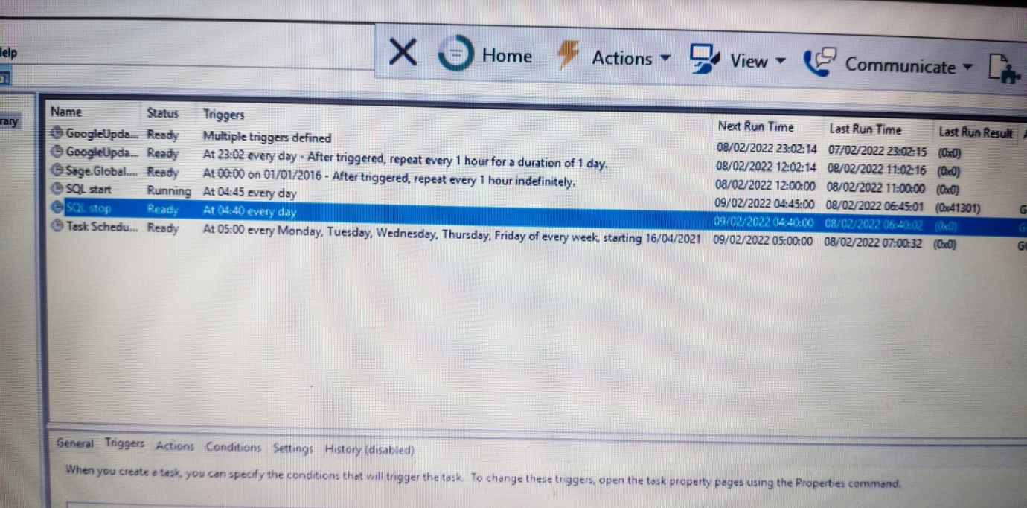

4. Double click the Task Schedular on the screen.

5. Click the Trigger option in the popup.

6. It will open the screen and you can change the time of the schedular.

7. After changing the time it will ask the Administrator Password That we Should ask the client to put the password on the screen.

8. Double click the SQL Stop in the screen and the time should be set to 20 minutes before the schedular time.

9.After setting this it will again ask the administrator password. That we Should ask the client to put the password on the screen.

10. Double click the SQL start in the screen and the time should be set to 5 minutes after the SQL stop time.

11. After setting this it will again ask the administrator password. That we Should ask the client to put the password on the screen.

Then the Task Schedular time is Successfully changed.

* + **Audit Trial import Url to Run the schedular manually**

[**http://localhost/oneclick**](http://localhost/oneclick)

**Path to find the one click function :-**

C:\xampp\htdocs\gch-sage\app\Http\Controllers

In the controller folder the file name is **SftpController** and the function name is

**end_to_end().**

**Issues in GCH SAGE :-**

Unable to connect the supplier import url.

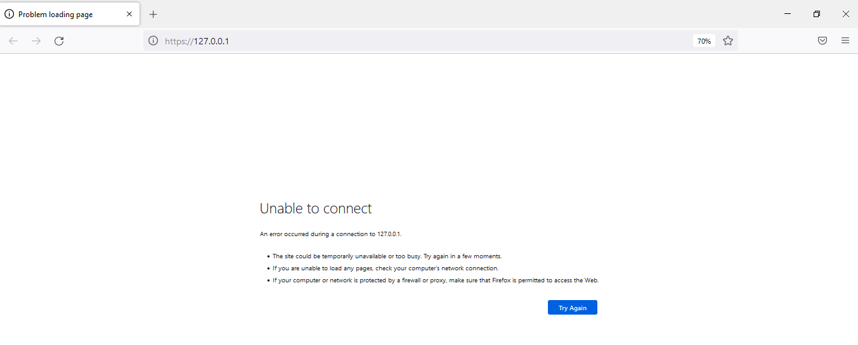

Just restart the local server in client side and refresh the page.

**Issue in Audit Trial import :-**

This issue comes when some user logged in sage during the schedular run time or the kafron server is not able to place the files in WinSCP folder.

If Audit Trial Import files are not gone to Sage , Then run the schedular manually

Before running the Schedular make sure that all the user should be logged out from the sage account. if any user is logged in sage account it will shows the error that

**( Username is already in use. )**