**eRunnerz Admin Panel User Guide**

**­­­­­INDEX**

Admin Module………………………………………………………………………………………………………. 2 - 5

Substation Module……………………………………………………………………………………………….. 6 - 9

Bikers Module………………………………………………………………………………………………….… 10 - 16

Vendor Module………………………………………………………………………………………………….. 17 - 21

Mange Delivery Module……………………………………………………………………………………… 22 - 26

Download Deliveries Module……………………………………………………………………………………. 27

Update Delivery Status Module………………………………………………………………………………… 28

Manage Permission Module……………………………………………………………………………………… 29

Create Shipment …………………………………………………………………………………………………….… 30

Report Module ……………………………………………………………………………………………………. 31-35

**Admin Module**

In this module you can view, add, edit and delete Admin. This module is accessed by super admin only.

In admin list you can view the quick information like name, mobile no, email and role of admin. There is a search box available for searching admin by name, email or mobile no. In the admin list page filters are also available where user can short name, mobile, email, role in descending and ascending orders by clicking on labels.

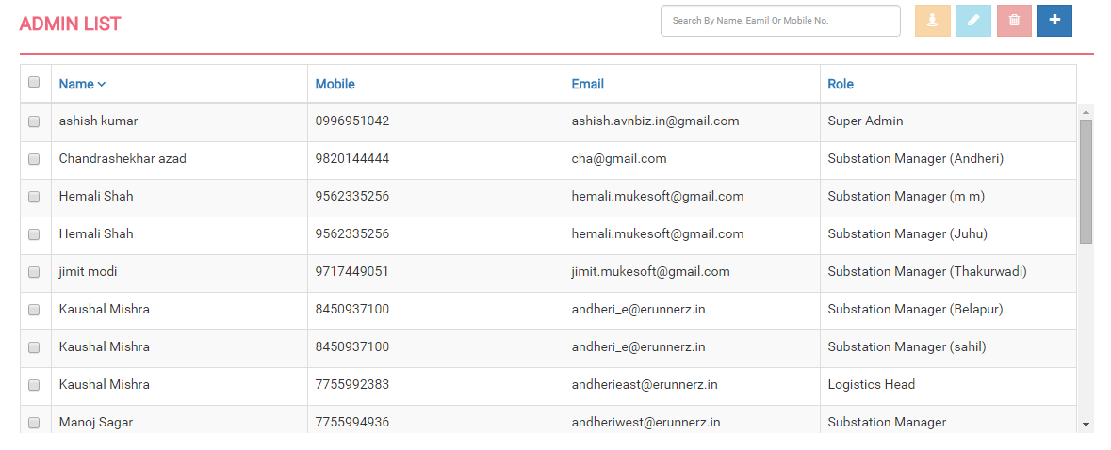

**Create Admin**

To create a new admin you can click "add new” button in the upper right corner. You will be directed to the admin information page. In admin information page you need to fill the basic information fields of admin. In admin information form first name, last name, email, mobile no., address, city, state, pin code, role are compulsory field. At the time of create admin you need to define role of that particular user. At the time of create admin password will be generated automatically and mail to that admin.

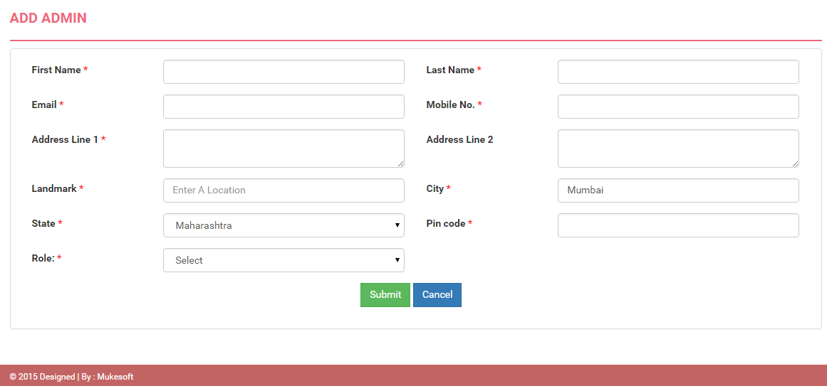

**Edit Admin**

Select an admin to "Edit" by using edit button in the upper right corner and update information and submit it.

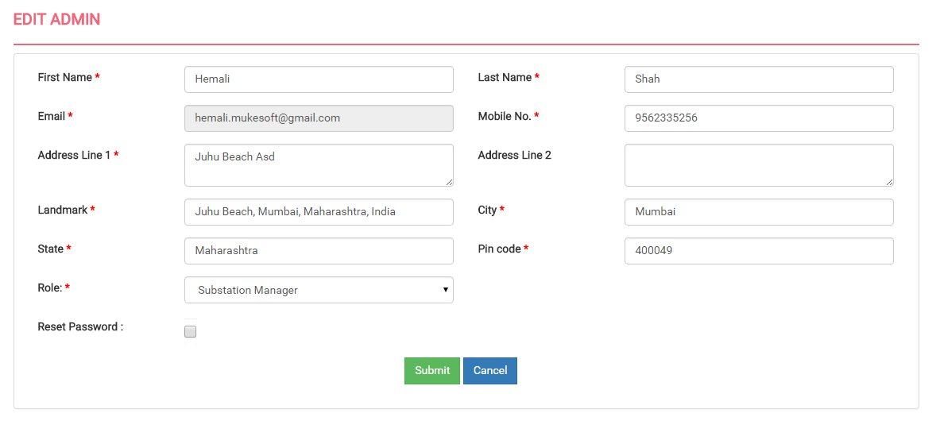

**View Admin**

Select an admin for view the details using upper right corner’s view button.

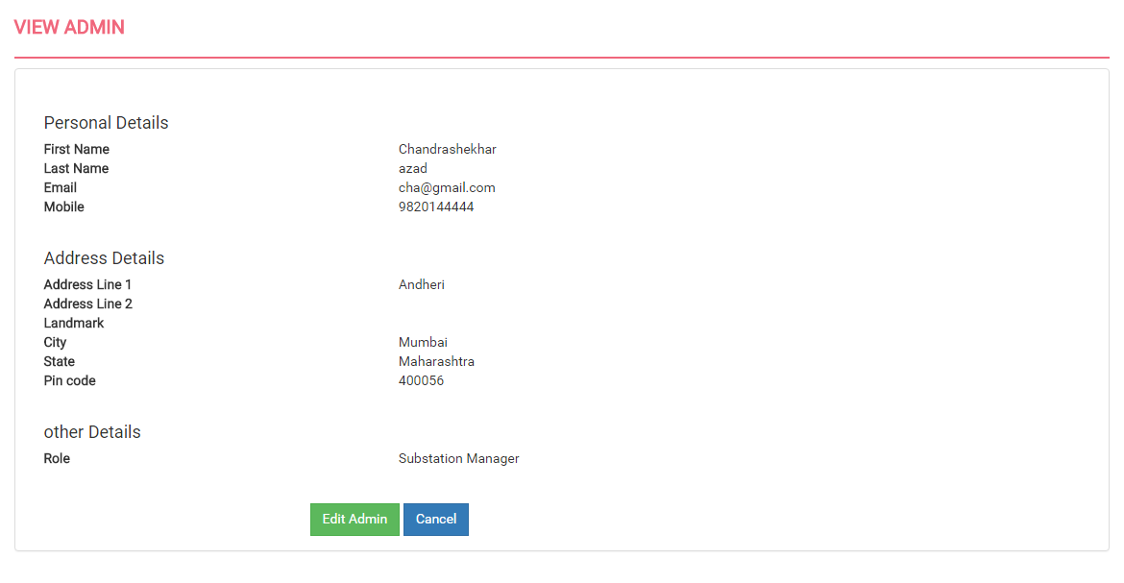

**Delete Admin**

You can delete the admin by selecting a particular admin or you can delete multiple admin at one click, using delete button.

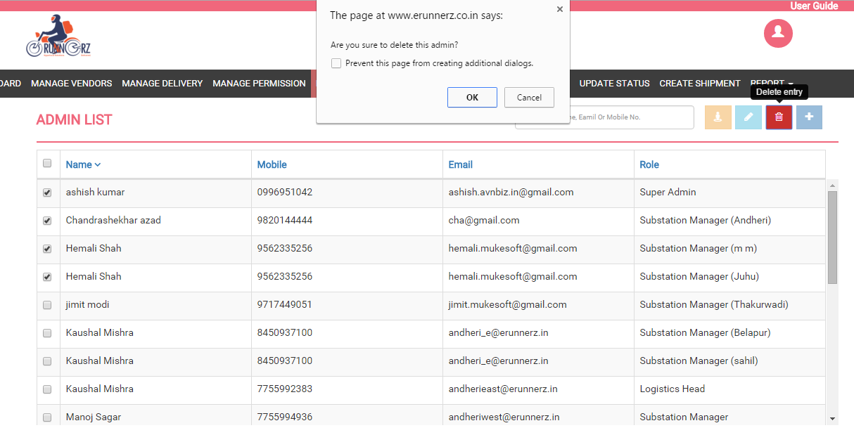

**Assigning Role to Admin**

You can assign role to admin at the time of create or edit admin page. There are three roles as below:

1. Super Admin
2. Substation Manager
3. Logistics Head

**Reset Password**

You can reset password of admin by selecting reset password check box from edit admin page and press submit button. Password will be mail to that admin.

**Substation Module**

In this module you can add, edit and delete Substation. In substation list you can view the quick information like name, mobile no, substation manager name, address, city and state of substation manager. There is a search box available for searching by mobile no., substation manager name. In the substation list page filters are also available where user can short name, mobile, address, substation manager name, state in descending and ascending orders by clicking on labels.

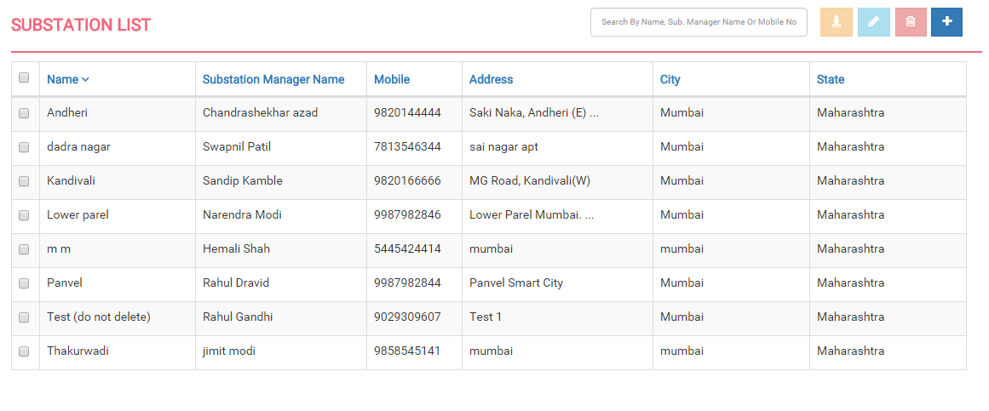

**Create Substation**

To create a new substation you can click "add new” button in the upper right corner. You will be directed to the substation information page. In substation information page you need to fill the basic information field of substation. In substation information form name, mobile no., address, city, state, pin code, sector, substation manager, substation pin code is compulsory field.

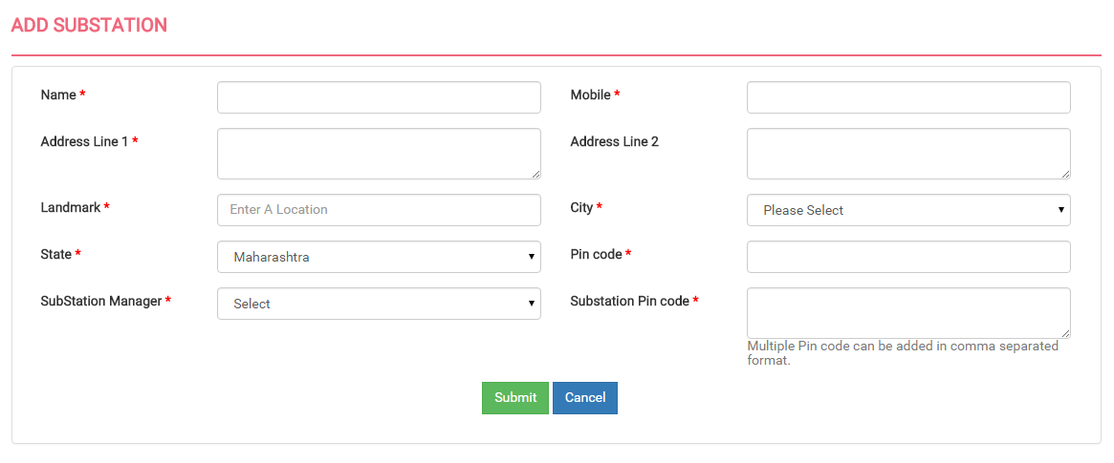

**Edit Substation**

Select a substation to "Edit" by using edit button in the upper right corner and update information and submit it.

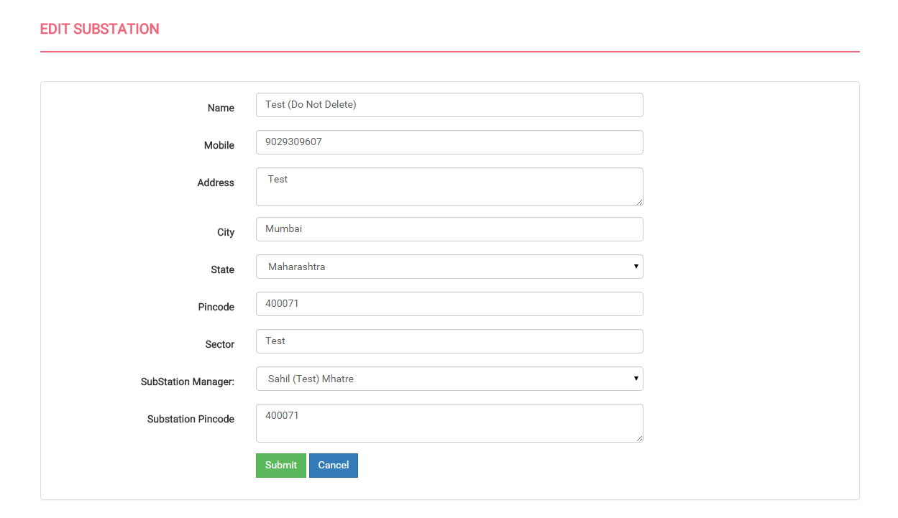

**View Substation**

Select a substation for view the details using upper right corner’s view button.

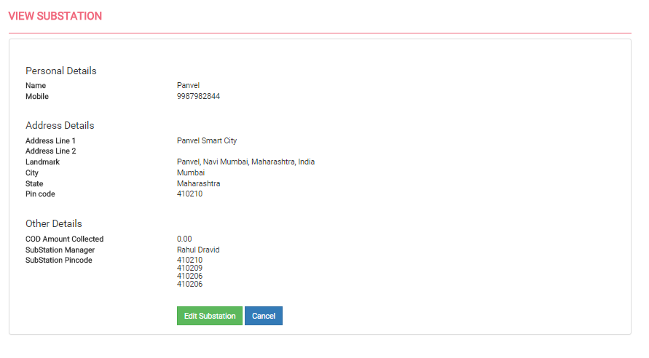

**Delete Substation**

You can delete the substation by selecting a particular substation or you can delete multiple substations at one click, using delete button.

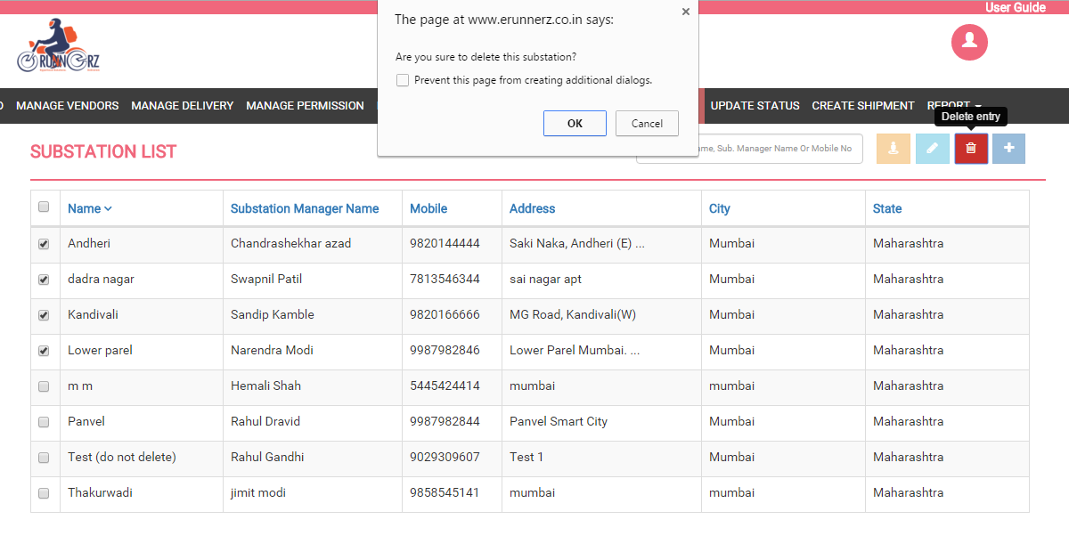

**Assigning Substation Manager to Substation**

To assign a substation manager to any substation first you need to create a admin account with role as substation manager. And then the list of all substation manager will be populated in the add/edit screen of substation and by selecting substation manager from dropdown you can assign substation manager to that substation.

**Bikers Module**

In this module you can add, edit and delete bikers. This will list all the bikers available. In case of Substation Manager Login he will only see the biker assigned to his substation. In bikers list you can view the quick information like name, mobile no, email, profile status, status, substation, COD amount and profile picture of biker. There is a search box available for searching biker by name, mobile no. and Substation. In the biker list page filters are also available where you can short name, mobile, email, profile status, status, substation, COD amount in descending and ascending orders by clicking on labels.

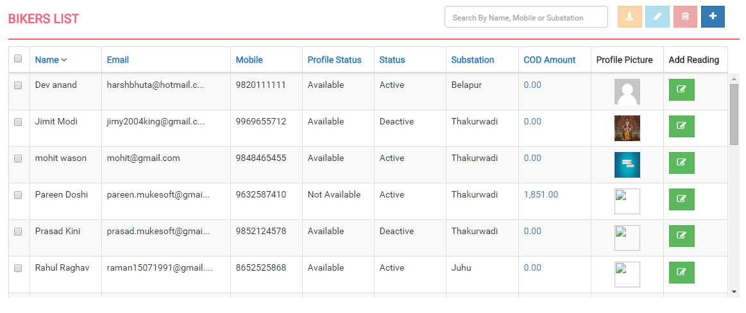

**Create Biker**

To create a new biker for substation you can click "add new" button in the upper right corner. You will be directed to the biker’s information page. In biker information page you need to fill the basic information field of biker. In biker information form first name, last name, email, mobile no., employee id, address, city, pin code, substation are compulsory field and all other fields are optional.

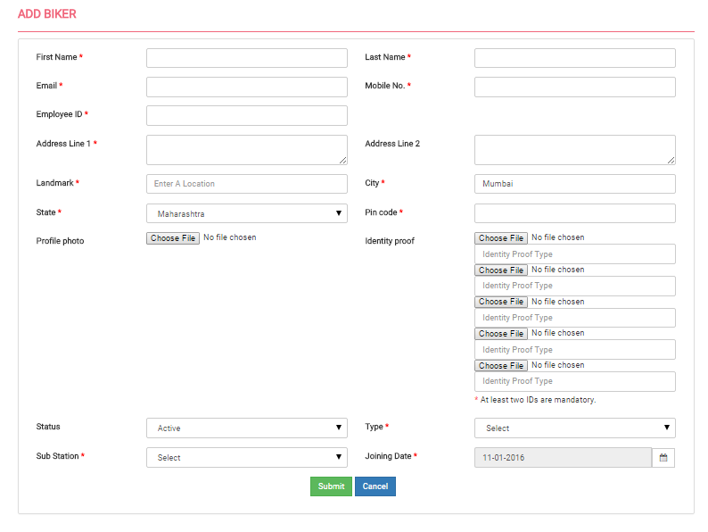

**Edit Biker**

Select a biker to "Edit" by using edit button in the upper right corner and update information and submit it.

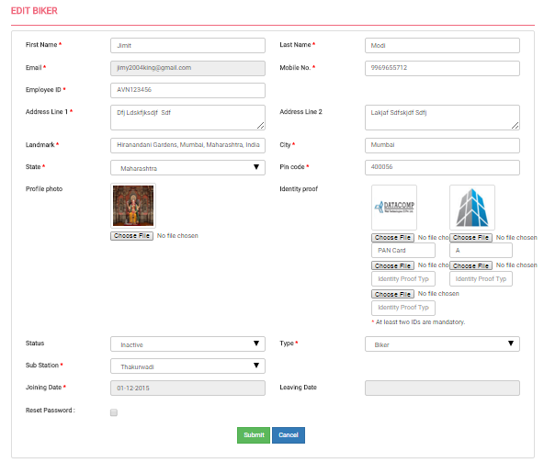

**View Biker**

Select a biker for view the details using upper right corner’s view button. Here you can download image and enlarge image by clicking on identity proof images.

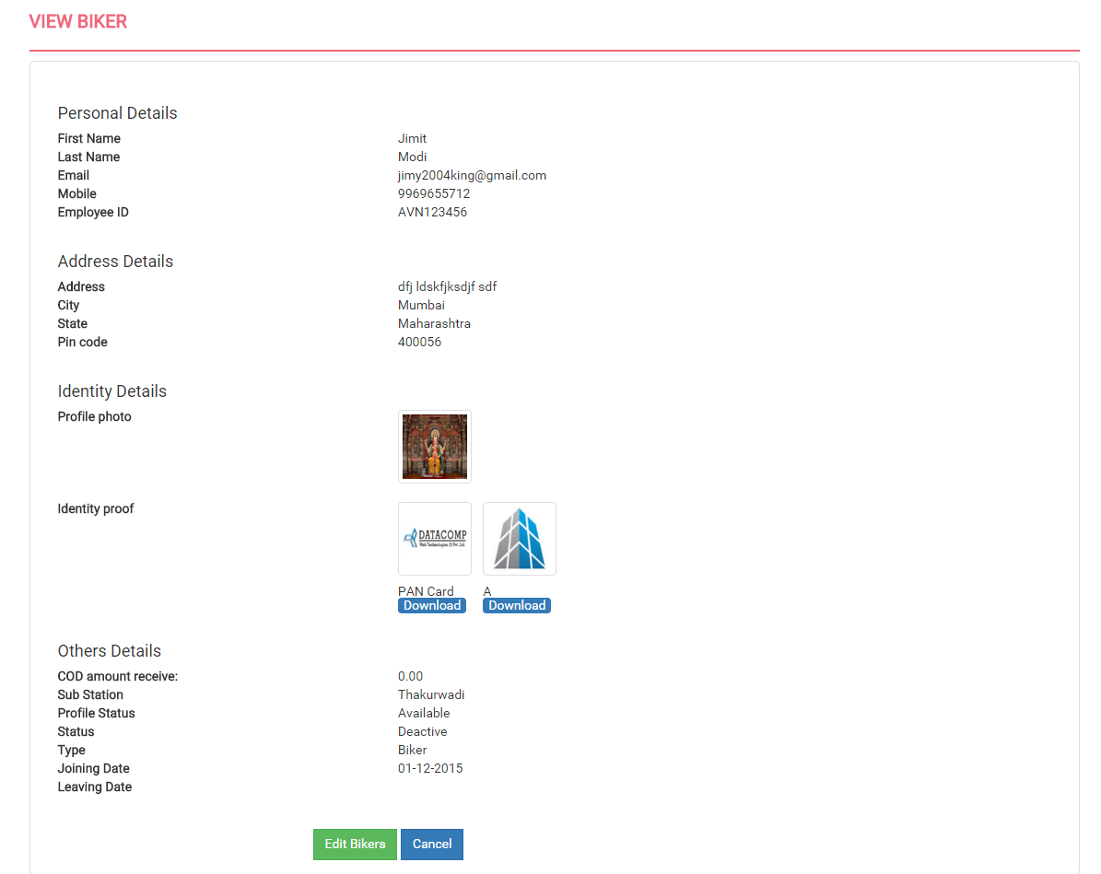

**Delete Biker**

You can delete the biker by selecting a particular biker or you can delete multiple bikers at one click, using delete button.

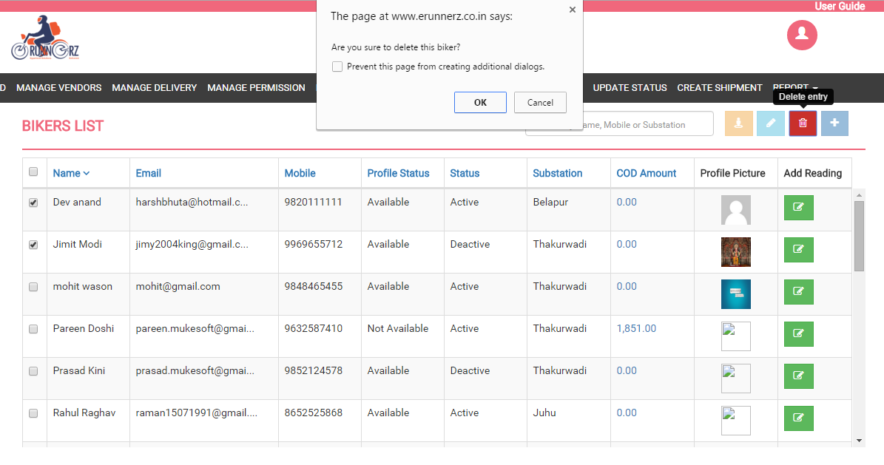

If any biker had pending or remaining COD amount than biker can’t be deleted.

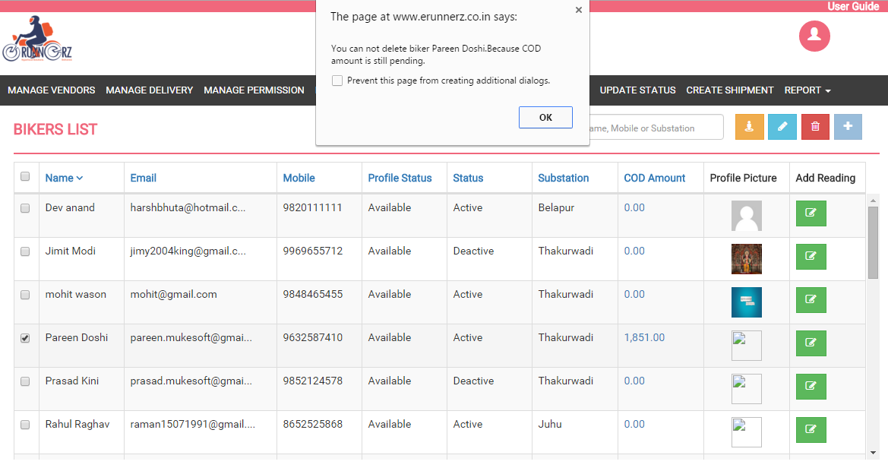

**Add Reading of Biker**

Every day when biker will come in Substation Manager will add their KMS reading. To do this click on "Add Reading" button under "Add Reading” you can add daily biker reading. After clicking on "Add Reading" button, popup will be open. In this popup you need to fill start reading, end reading and date field and then press save button will add reading of biker.

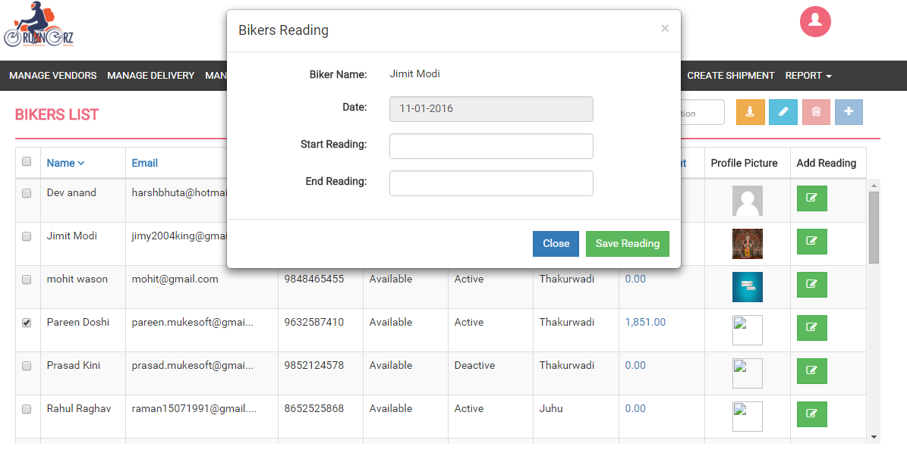

**Add COD of Biker**

If user is substation manager then only he can add cod, on clicking "COD Amount" under "COD Amount column" you can add COD received from biker. We are showing only two days biker record of respective biker. By clicking on checkbox admin can add COD Amount. Selected COD Amount is deducting from biker account and the amount is adding in substation manager account.

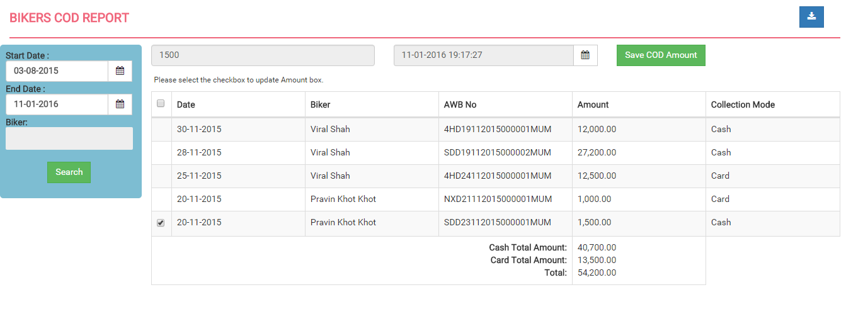

**Assigning Biker to Substation**

To assign a biker to any substation first you need to create substation. And then the list of all substation will be populated in the add/edit screen of biker and by selecting substation from dropdown you can assign substation to biker.

**Reset Password**

You can reset password of biker by selecting reset password check box from edit screen of biker and press submit button. Password will be mail to that biker.

**Vendor Module**

In this module you can add, edit and delete Vendor. In vendor list you can view the quick information like contact person name, company name, mobile no, email and status of vendor. There is a search box available for searching vendor by name, company name, email or mobile no. In the vendor list page filters are also available where you can short contact person name, company name, mobile no, email and status in descending and ascending orders by clicking on labels.

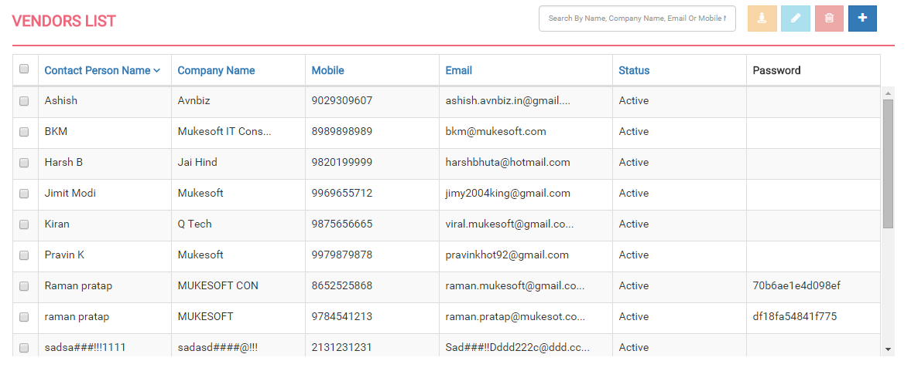

**Create Vendor**

To create a new vendor you can click "add new” button in the upper right corner. You will be directed to the vendor information page. In vendor information page you need to fill the basic information field of vendor. In vendor information form name, email, mobile no., address, city, state, pin code and status are compulsory field. At the time of create vendor you need to define status of that particular vendor. At the time of create vendor password will be generated automatically and mail to that vendor.

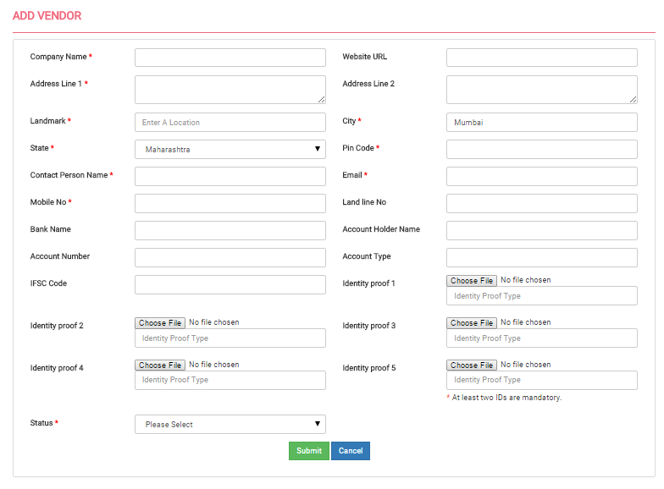

**Edit Vendor**

Select a vendor to "Edit" by using edit button in the upper right corner and update information and submit it.

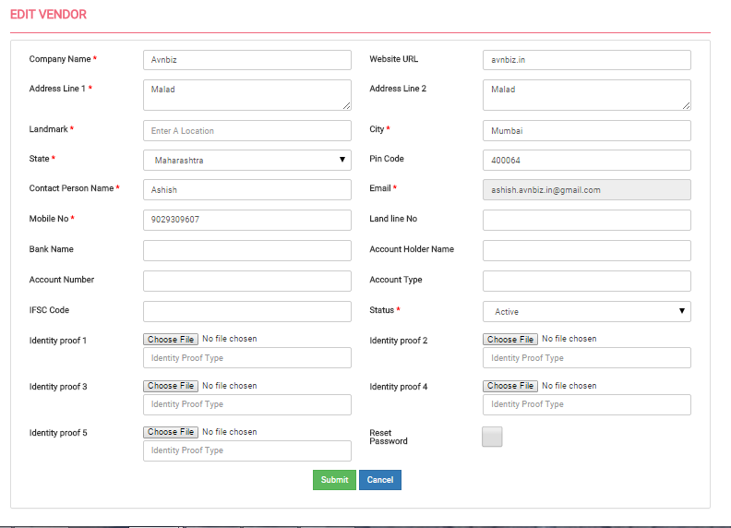

**View Vendor**

Select a vendor for view the details using upper right corner view button. Here you can download image and enlarge image by clicking on identity proof images.

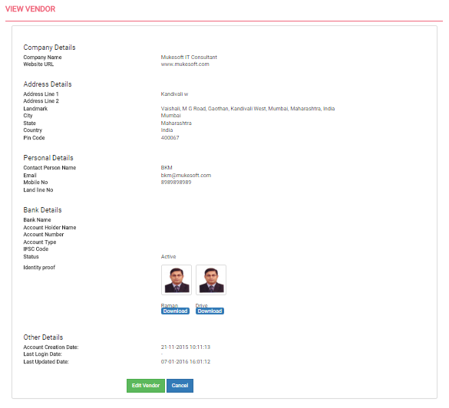

**Delete Vendor**

You can delete the vendor by selecting a particular vendor or you can delete multiple vendors at one click, using delete button.

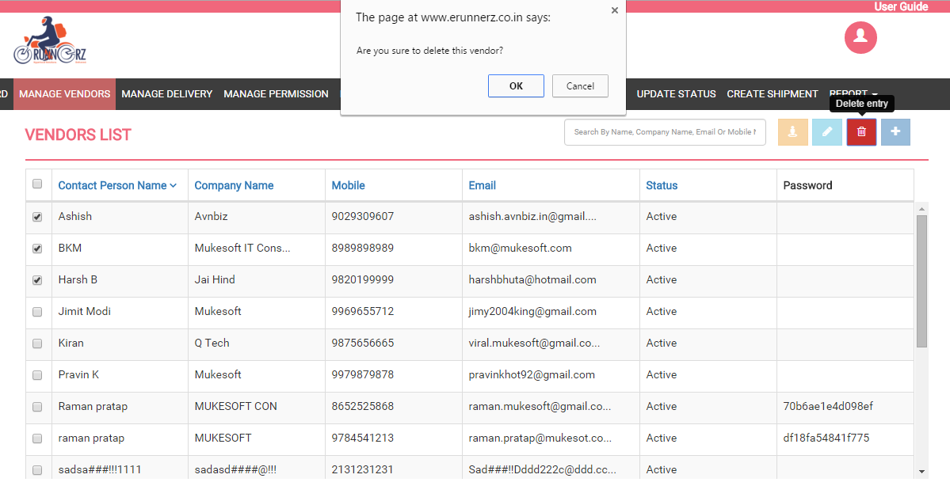

**Assigning Status to Vendor**

You can assign status to vendor at the time of create or edit vendor. There are three statues as below:

1. Active: Vendor will able to login and create new order.
2. Hold: Vendor will able to login but can’t create new order.
3. In active: Vendor will not able to login and create new order.

**Reset Password**

You can reset password of vendor by selecting reset password check box from edit vendor page and press submit button. Password will be mail to that vendor.

**Mange Delivery Module**

In this module, initially left hand side of page we list down all the deliveries and right hand side of page us showing current location of biker’s. initially we are showing today deliveries with the following sequence:

1. NEW
2. ASSIGNED
3. IN TRANSIT
4. AT SUBSTATION
5. DELIVERED
6. RETURNED

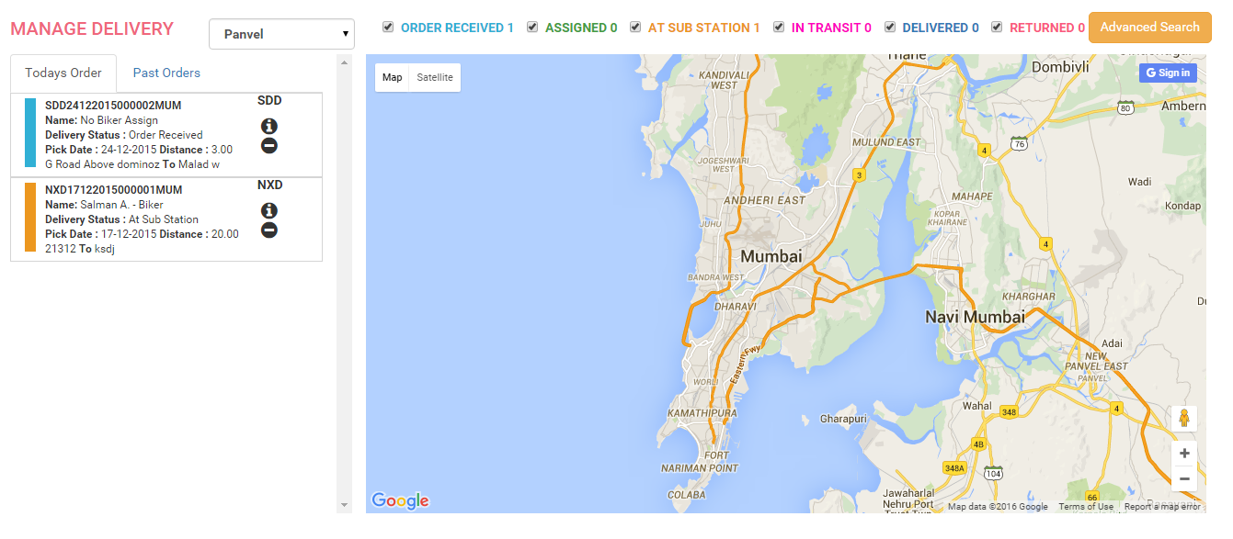

On click of AWB no. the start and end location with direction will be displayed for that order.

On clicking “more info” icon which is located at left side of page we will get popup and in that popup all the details of that order will be displayed such as biker name, biker mobile, distance, pickup address, drop address and status history.

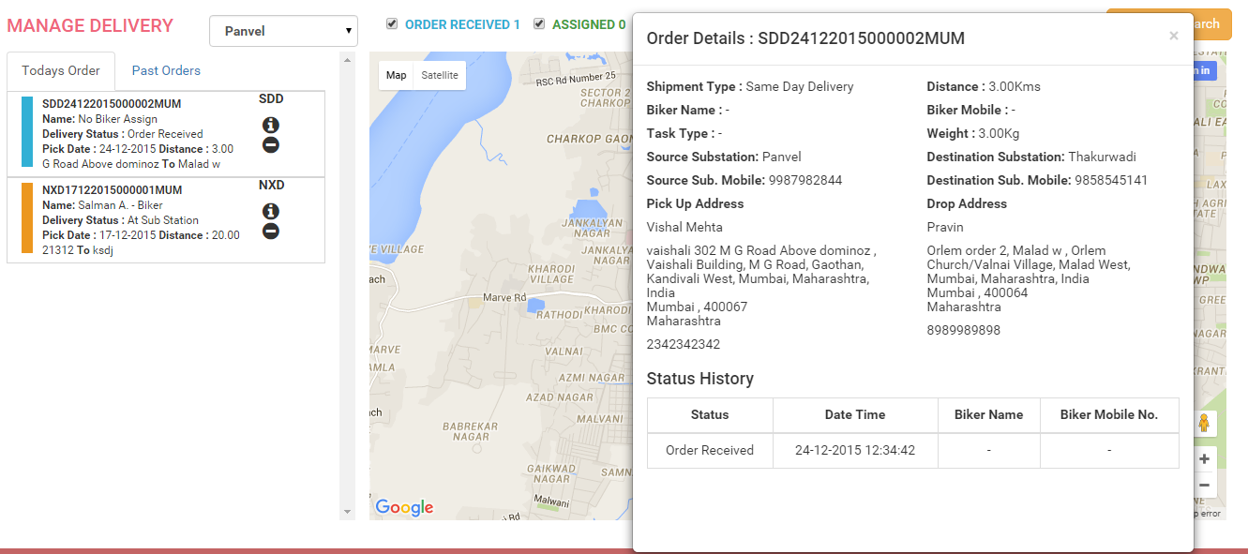

**Filters**

1. **Using Delivery Status:** We are showing all the delivery status at the top by selecting them we can filter deliveries according selected status.

panel.PNG

1. **Advance Search:** In advance search provide number of option to filter deliveries such as delivery status, biker name, start date and end date of order.

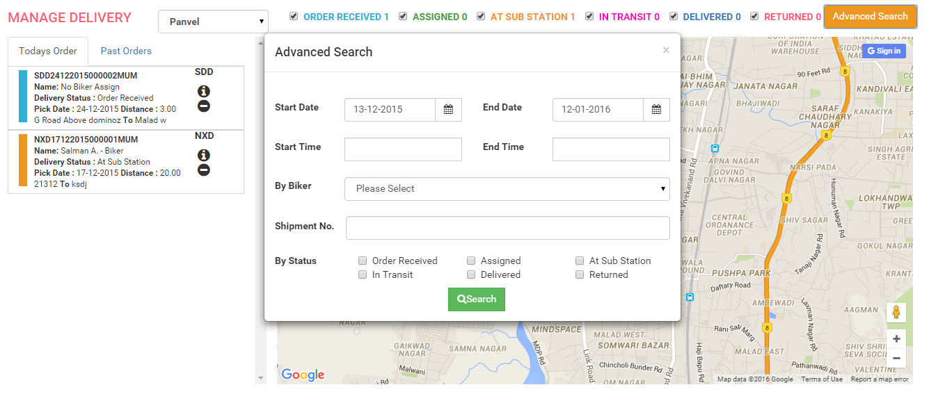

**Assign Biker and Delivery type**

On clicking biker we are showing two drop boxes. First is for assign delivery type and second is for assign biker which is listed in drop box. There are three type of delivery as given below:

1. Pick only: In this type biker will pickup order only.
2. Delivery Only: In this type biker will delivered order only.
3. Pickup and Delivery: In this type of order biker will pickup and deliver that order.

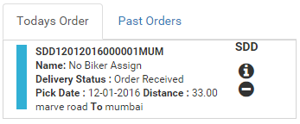

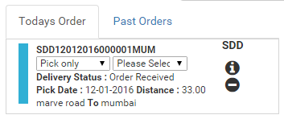

**Change Delivery Status**

By clicking on delivery status we can change the delivery status.



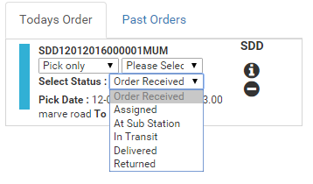

**Transfer to Substation**

On clicking “transfer to substation” button which is located at left hand side of page we get drop box of all substation on selecting substation you get alert “want to transfer to substation?” if you click on ok action will perform means order will removed from current substation and it get assigned selected substation.



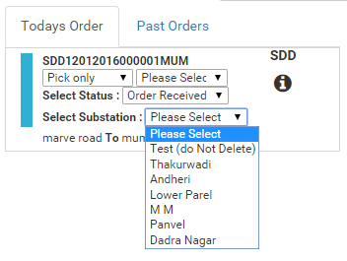

**Download Deliveries Module**

Using this module you can download all the deliveries in excel format. In this module you need to select start date and end date then it gives excel sheet of deliveries in between selected date.

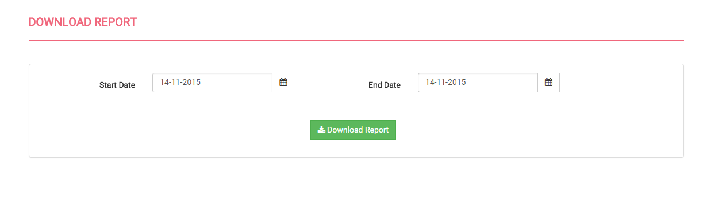

**Update Status Module**

Using this module you change the status of single or multiple deliveries at a time. To do this you need to enter status and AWB no. of deliveries. Multiple AWB no. need to be comma separated.

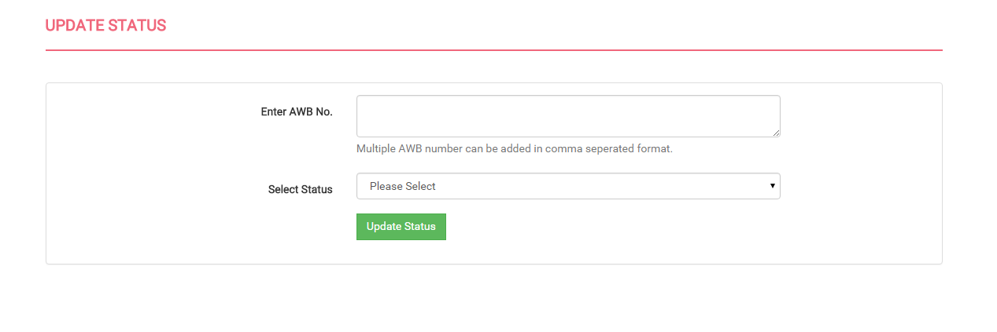

**Manage Permission Module**

In this module you can specify the access of module to role and this access can be modified and view. This module can access only by super admin.

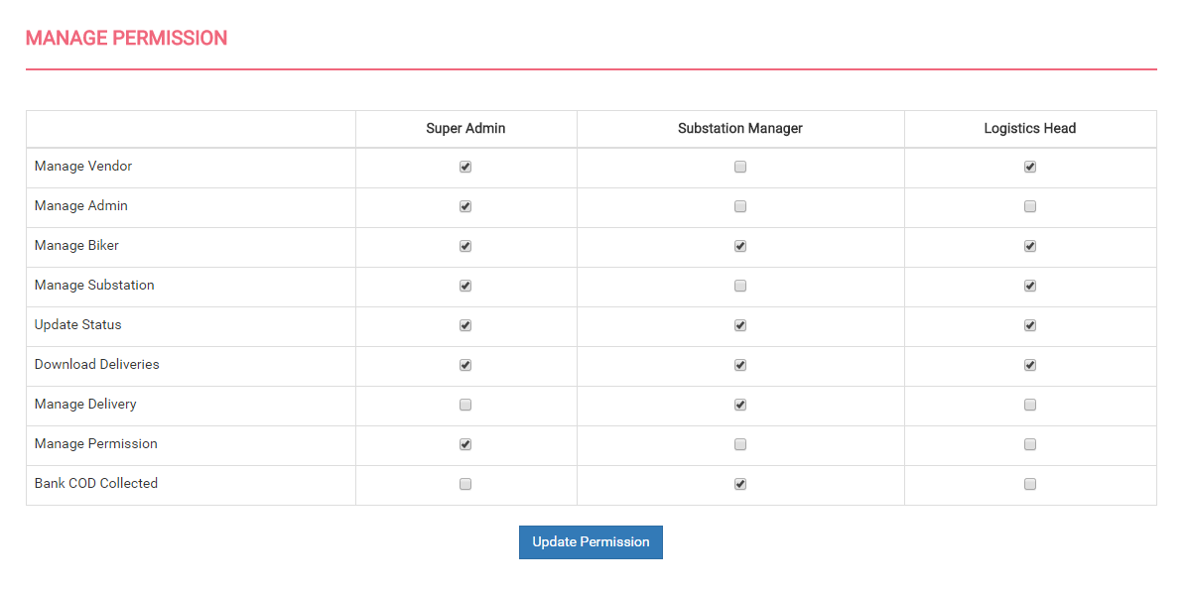

**Create Shipment**

In this module super admin or substation manager able to create shipment on behalf of vendor.

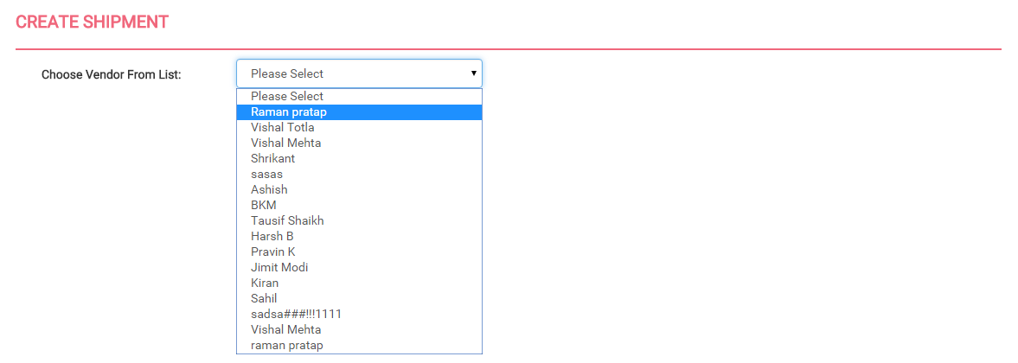

**Report Module**

In this module admin or substation manager view various reports like shipment report, account and billing report, biker report, and bank COD report.

**Shipment Report**

In this report admin or substation manager can view last month’s shipment details.

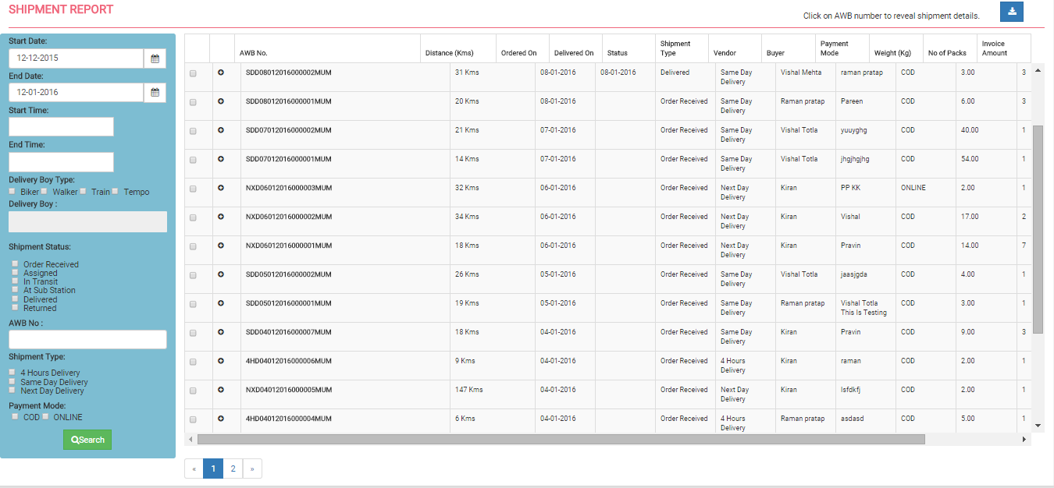

By clicking AWB no it shows the advanced details of that shipment.

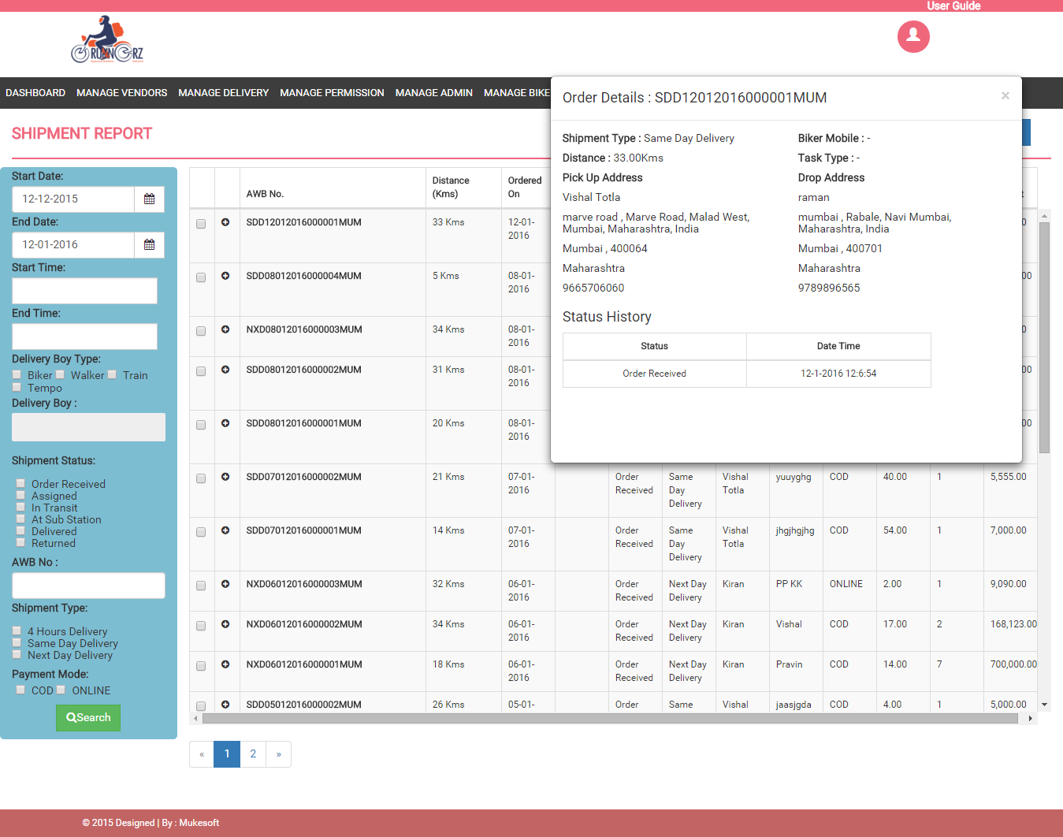

By clicking plus button can view package details of particular shipment.

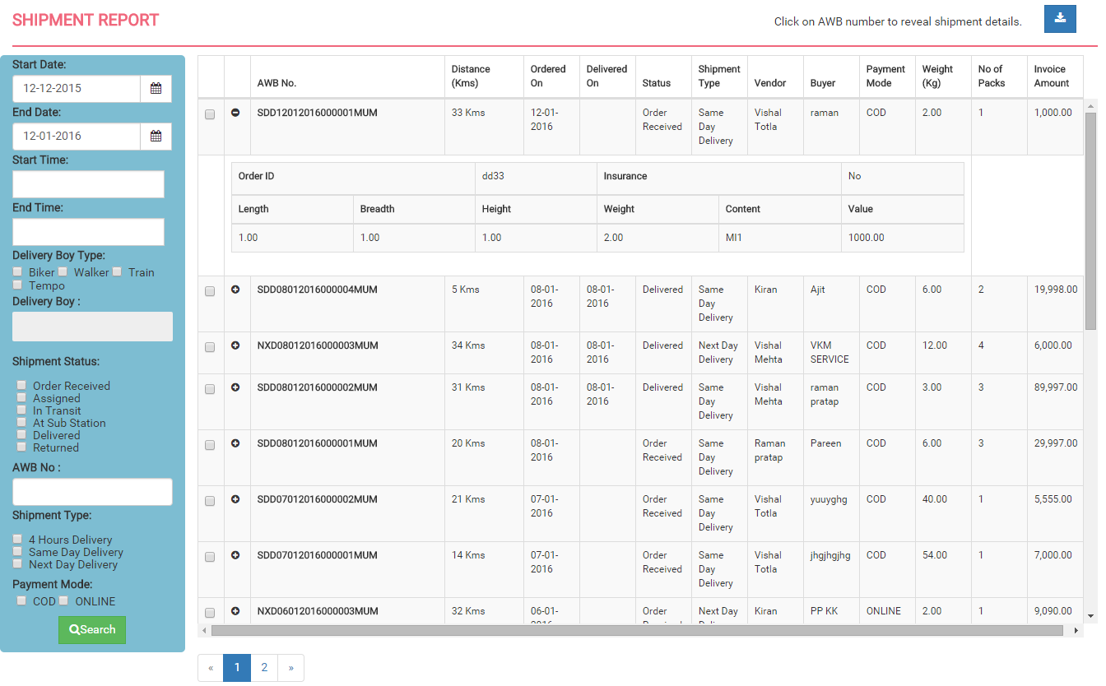

There is various search options available like by date, by time, delivery boy type, delivery boy name, shipment status, AWB no, shipment type and payment mode. There is also excel download option for shipment data, by filtering data can also download that shipments only and by clicking on checkbox download only that shipment data. User can also download a particular record by selecting the record using checkbox.

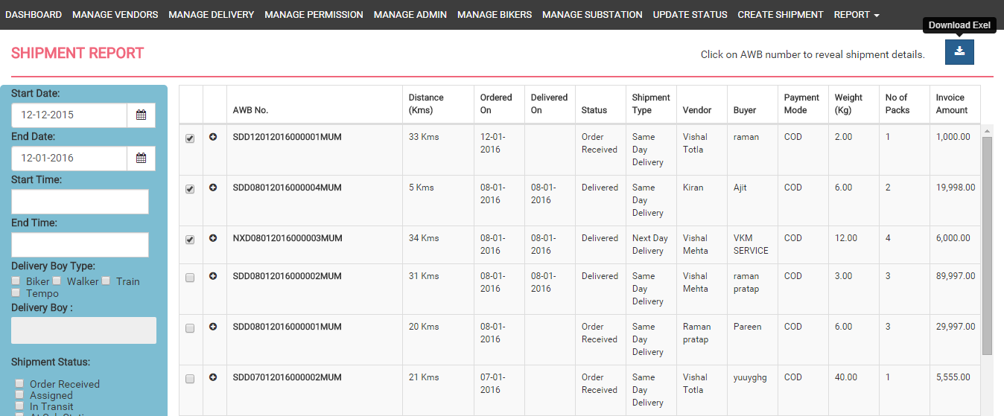

**Billing and Account Report**

In this report super admin can view various shipments that are delivered and their various amounts. This report is particularly used for billing calculation. This report having filters of date, shipment type, payment mode and vendor name. This report having excel download option.

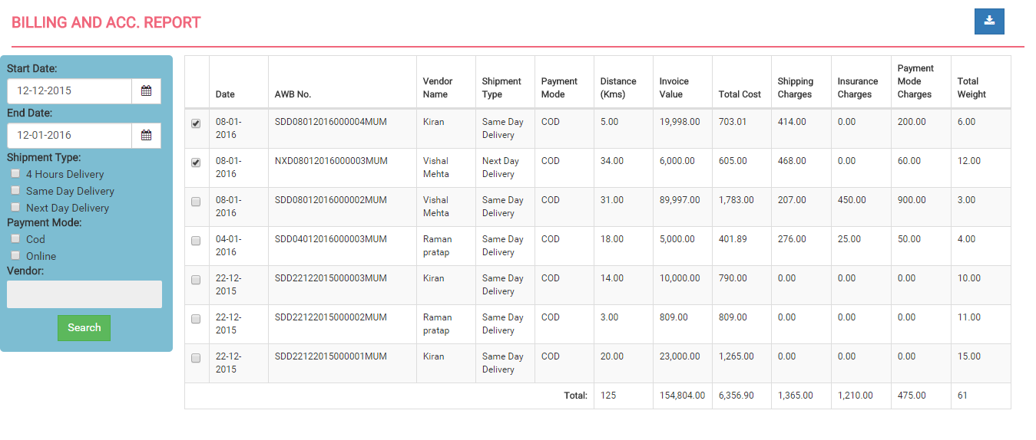

**Biker Report**

In this report super admin or substation manager can view and analyse biker’s daily performance. It shows biker total delivered shipments, start reading, end reading, actual travel of biker and COD collected by biker. This report having filter date, delivery boy type, delivery boy name. This report having excel download option.

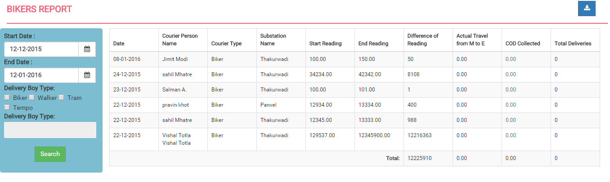

**Bank COD Report**

In this report super admin can only view the details. The substation manager can add their COD amount to the bank. This report shows the shipments that delivered and having cash on delivery type. This report having filter date, biker name, bank reference number and collection mode. This report having excel download option.

